The BioDiversity Project
Lesson Title: The Beauty of Bats

Teacher: Ms. Gricelda Meraz
Grade Level: 6th
Time: 30 minutes +10 minute introduction

Adapted from: https://www.fws.gov/midwest/Endangered/mammals/inba/curriculum/Chapter9.pdf

AZ State Science Standard: | 6.L2U1.14:  - Construct a model that shows the cycling of matter and flow of energy in ecosystems.
Learning Objective: | - Students will define the different adaptations of both insectivorous and nectivorous bats.  - Students will describe why bats are beneficial to humans.
Language Objective: (Optional) | N/A
Scientist of the Week: | Dr Rodrigo A. Medellín  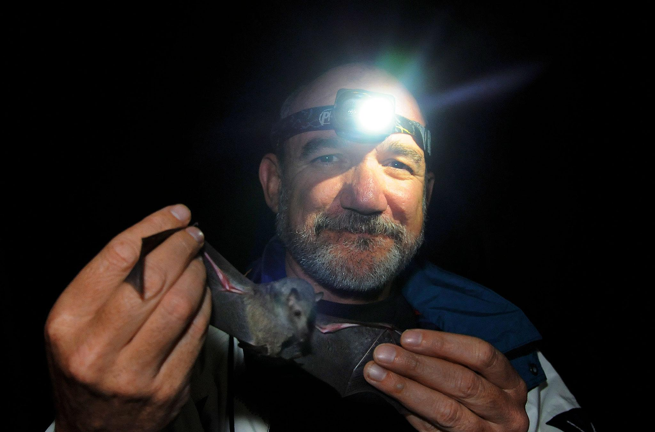  * He was born in 1957 in Mexico City  * Mexican ecologist and academic known for his work in the field of bat conservation.  * Founding Director of the Latin American Network for Bat Conservation.  * He is known as the “Bat Man of Mexico”  *He says he was already determined to be a bat biologist when he held a bat for the first time at just 13 years old

Vocabulary |  |  | Materials
Provide a bulleted, alphabetized list of words that students will hear, speak, write, and/or read about in the lesson. Please do not list more than 4-5 words. These words must be integral to developing content understanding. You may copy and paste these directly from the Scope and Sequence Guide document.  - Insectivorous  - Feeding on or adapted for feeding on insects  - Nectivorous  - feeding on or adapted for feeding on nectar  - Conservation  - the care and protection of resources so that they can persist for future generations  - Nectar  - a sugary fluid secreted by plants, especially in flowers to encourage pollination by insects and other pollinators  - Pollen  - a fine powdery substance, typically yellow, microspore in a seed plant appearing as dust.  - Adaptation  - The behaviors and physical characteristics of animals that allow them to live successfully in their environment. |  |  | Provide a bulleted and hyperlinked list of relevant materials for the lesson.  YouTube Videos:  Bats' Desert Fruit Feast | Wings of Life  polinización por murciélagos  Activity sources:  https://www.batcon.org/  https://www.fws.gov/midwest/Endangered/mammals/inba/curriculum/Chapter9.pdf  Presentations:  The Beauty of Bats  Español: La belleza de los murciélagos
Seasonality: (If more specificity is required, please note date/time range under the season)

Highlight which season(s) your lesson would be most suited to. When working with the natural world, it is important to keep this in mind for your planning! Some activities are possible for a brief window of time while others may be appropriate during any time of year.

Monsoons  July-Sept. | Autumn  Oct.-Nov. | Winter  Dec.- Feb. |  | Spring  Mar.-Apr. | Dry Summer  May-June
Guiding Questions:

- How do the ecosystem services from nectivorous bats differ from insectivorous bats?
- How do bats benefit the lives of humans?

5E Steps | Teacher Strategies | Student Behavior
Engagement/Introductory Activity:  This is what you will do to get the students engaged in and excited about the topic of the lesson! It should also provide an opportunity for you to get an idea of what they do (and do not) already know, and the assumptions that they have going into the lesson. | What you will do. Include hyperlinks to any teaching tools.  Interns will lead an introduction activity that shows students why bats should be important to them.  Interns will give students a list of some plants that bats help pollinate and explain how they pollinate these plants.  Interns will give students an horchata recipe and tell them to cross out any ingredients that we would not have without bats.  Source:  https://www.fws.gov/midwest/Endangered/mammals/inba/curriculum/Chapter9.pdf | What students will do. Include detailed instructions written for students to read and comprehend as well as any hyperlinks to documents, sites, or videos they need to access in order to complete the activity.  Students will be given a list of plants that bats help “grow”.  Students will look at the horchata recipe on Nearpod and comment which ingredients would not exist without bats.  (6 minutes)
Exploratory Activity:  Provide step-by-step instructions on what the teacher and students will do in this activity to gain new skills and/or knowledge. Attach worksheets, PowerPoints, video links, or other material used to this section. | Interns will show students a video about bat adaptations.  bat video-Bats' Desert Fruit Feast | Wings of Life  En espanol:  polinización por murciélagos  Interns will then present a google slide about nectivorous and insectivorous bats there will also be about bats and saguaros and how they help Tohono O'odham saguaro fruit collection  Slides:  The Beauty of Bats  Español: La belleza de los murciélagos | Students will watch the video and take notes on any adaptations they think the bats are using in the video.  Students will then take notes on a short presentation about nectivorous and insectivorous bats.  (15 minute)
Explain:  What questions or prompts will you use to get students to explain their observations or to explain what the outcomes of the activity that they participated in were? This should provide an opportunity for students to communicate their new understandings, as well as to articulate what they still do not understand. | Venn diagram  For this activity, interns will ask students to have a piece of paper and a pencil/pen ready at the beginning of class.  The interns will instruct the students in an explanatory activity through a physical interaction.  Ask the students to interact within the chat box or ask questions to the Interns. | Students will take out the blank piece of paper they had gotten ready at the beginning of class and create a Venn diagram.  Through the creation of a Venn Diagram the students will recall the two different types of bats by comparing and contrasting (Nectivorous and Insectivorous)  (6 minutes)
Extension Activity/Questions:  This section provides an opportunity for students to connect the knowledge that they have gained to other contexts – can they take what they learned and logically expand upon it, or apply it to alternate situations? Provide one or two additional ideas for activities that students can use to expand upon the new knowledge that they have gained. | Now that we have talked about different kinds of bats and how they help people, let's talk about how we help bats!  Interns will show a quick video about a bat conservation technique:  https://www.youtube.com/watch?v=phHxGe2Usxc&feature=emb_imp_woyt  Interns will then ask how the technique works and how it helps bats.  Interns will define what conservation is.  How does this technique work?  How does it help bats? | Students will watch the video and observe the bat conservation technique. Students will then discuss how the technique works and how it helps bats.  (5 minutes)
Evaluation Activity:  How will you evaluate whether or not the students have achieved the learning objective(s) of the lesson? | kahoot- fun way to end it  Teachers will present Kahoot links/code to join. Students will be asked questions to measure what they learned from this lesson and to see their understanding.  https://kahoot.com/ | Students will answer questions to measure their understanding of this lesson.  They will be given a couple seconds to answer each question to the best of their ability.  (5 minutes)

