The Bio/Diversity Project
Lesson Title: Specific Pollinator: Bees

Teacher: Anna Rogers and Chloe Brooks
Grade Level: 7th
Time: 35 minutes

Adapted from: How Can we Save the Bees, Biodiversity Bee Week
AZ State Science Standard: | 7.L1U1.10:  - Develop and use a model to explain how cells, tissues, and organ systems maintain life (animals).  7.L1U1.11  - Construct an explanation for how organisms maintain internal stability and evaluate the effect of the external factors on organisms’ internal stability.
Learning Objective: | - Students will be able to describe the diversity of bees in the Sonoran Desert  - Students will be able to discuss the different type of bees in a colony and their roles
Language Objective: (Optional) | N/A
Scientist of the Week: | 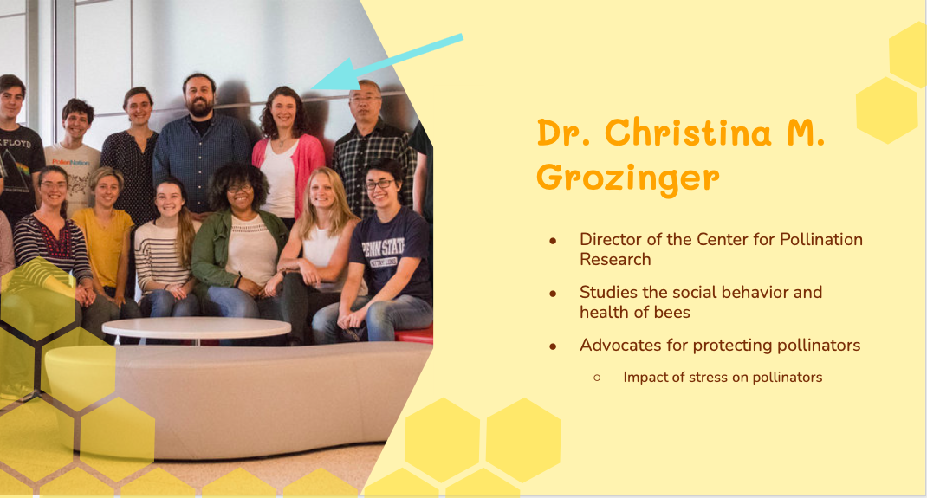

Vocabulary |  |  | Materials
- Colony  - Honey  - Queen  - Worker  - Drone |  |  | - Slides  - iNaturalist Sonoran Desert Native Bees  - All About Bees Kahoot
Seasonality: (If more specificity is required, please note date/time range under the season)

Highlight which season(s) your lesson would be most suited to. When working with the natural world, it is important to keep this in mind for your planning! Some activities are possible for a brief window of time while others may be appropriate during any time of year.

Monsoons  July-Sept. | Autumn  Oct.-Nov. | Winter  Dec.- Feb. |  | Spring  Mar.-Apr. | Dry Summer  May-June
Guiding Questions:

- How do bees work together in a hive to survive and pollinate plants?
- Why are bees such important pollinators, especially in the Sonoran Desert?

5E Steps | Teacher Strategies | Student Behavior
Engagement/Introductory Activity:  This is what you will do to get the students engaged in and excited about the topic of the lesson! It should also provide an opportunity for you to get an idea of what they do (and do not) already know, and the assumptions that they have going into the lesson. | - Scientist of the Week  - Ask students about anything fun that’s happened in their lives the past week(s). Keep to around 1 min  - Warm-up activity: ask the students to come up with a feature of a flower that would be attractive to bees. After 30 secs, have them share their answers outloud or in the chat.  - Possible answers include: sweet smell, colorful flower, patterns on flowers, open structured flowers, flowers that release pollen when vibrated  - Go over the example of flowers with UV pattern nectar guides which can guide bees to pollinate-able flowers. | - Students should recall prior knowledge from the plant adaptations to pollinators lesson to come up with a flower trait that would be attractive to bees  - They should try and come up with individual traits, but it’s ok if they can name specific flowers instead
Exploratory Activity:  Provide step-by-step instructions on what the teacher and students will do in this activity to gain new skills and/or knowledge. Attach worksheets, PowerPoints, video links, or other material used to this section. | - Briefly go over the facts that there might be 1000 different bee species in the sonoran desert and 80% of plants near us (more specifically the tucson mountain region) are pollinated by bees  - Introduce the iNaturalist research activity: link the iNaturalist website in the zoom chat and instruct students to go to the website. also open a website so they can walk through it with the instructors.  - click on the arrow next to “recent observations” (point this out on the screen), instruct students to look through the different bee sightings near them and find one species of bee they didn’t know of before.  - After about 1-2 mins have them type their bee species in zoom chat. then go to the next slide in the presentation where they can see some prepicked examples with pictures.  - comment on if anybody had the same answer as the examples or another student. | - Students should try to engage and develop basic research skills in looking through the iNaturalist website to discover what species of bees are native to their area.  - They should recognize how this data is taken from civilians and how this is a resource they could possibly contribute to if they were interested.  - Students should connect this research activity to recognizing the great diversity of bee species that exist and that not all bees look the same.
Explain:  What questions or prompts will you use to get students to explain their observations or to explain what the outcomes of the activity that they participated in were? This should provide an opportunity for students to communicate their new understandings, as well as to articulate what they still do not understand. | - Go over the 3 different types of bees that can be found in a colony: Queen bee, worker bee, and drone.  - Go through each and talk about the roles that each one is responsible for in the hive  - Queen: mother to all the bees in the hive, can string multiple times, cared for by other bees  - Worker: all female, guard and clean the hive, gather nectar, can sting once  - Drone: eat honey, can’t sting, mate with queen  - Activity: give the students 1 min and have them come up with a human role/job that is similar to each of the 3 types of bees (or less if they can’t come up with an answer in time).  - Have students draw the roles they came up with on a piece of paper to make “hive” with people.  - Bonus if a student can think of one workplace that could have all 3 roles (like maybe an office)  - Example answers could be: A worker is like a teacher, or a security guard. The queen is like the mother to the hive. The drone could be like a billionaire that doesn’t work and eats all the time  - Have 2 students share the answers they came up with. | - Students should try to understand the differences between the different kinds of bees that exist in the have.  - students should use their understanding of bee roles in a colony to come up with parallels to roles in human society.  - they should be ready to share their thinking with the class.
Extension Activity/Questions:  This section provides an opportunity for students to connect the knowledge that they have gained to other contexts – can they take what they learned and logically expand upon it, or apply it to alternate situations? Provide one or two additional ideas for activities that students can use to expand upon the new knowledge that they have gained. | - Introduce the game of charades with the students  - Play one round of charades and have the students guess what object you are acting out  - Ask the students why it is more difficult to guess the object when playing charades  - Prompt them to talk about not being able to use words  - Explain that bees need to communicate with each other but can’t use words  - Show the “Bee Dance Language” video  - Introduce our “bee friend” on the next slide and use them to show a bee waggle dance  - If time allows, give the students different scenarios and ask them how the waggle dance would change in each scenario  - The food is farther away  - The food is closer  - The food is more to the left  - The food is more to the right  - Demonstrate how each of the scenarios would change the bee waggle dance using the “bee friend” | - Students will pay attention to the game of charades and try to guess the objects the instructor is acting out  - Students will reflect on what was hard about the game and make connection between the movement and communication  - Watch the “Bee Dance Language” video  - Watch the Waggle Dance demonstration and provide ideas on how the dance would change in the different scenarios presented to them
Evaluation Activity:  How will you evaluate whether or not the students have achieved the learning objective(s) of the lesson? | - Start the All About Bees Kahoot  - What is NOT important for bees?  - Nectar  - Pollen  - Honey  - Grass  - There are only 10 species of bees in the Sonoran Desert  - True  - False  - What type of bee is the mom to all the other bees?  - Queen  - Drone  - Worker  - Spelling  - How do bees communicate to each other?  - By whispering  - By dancing  - By bumping into each other  - By texting  - Drone bees can’t sting  - True  - False | - Students will connect to the Kahoot and play along

