The Bio/Diversity Project
Lesson Title: Self-pollination vs Cross-pollination

Teacher: Rachel Morris and Shelbi Gowin
Grade Level: 7th
Time: 45 minutes

Adapted from:

AZ State Science Standard: | - 7.L1U1.11  Construct an explanation for how organisms maintain internal stability and evaluate the effect of the external factors on organisms’ internal stability.
Learning Objective: | - Students will be able to define self-pollination and cross-pollination.  - Students will be able to identify key differences between self-pollination and cross-pollination.
Language Objective: (Optional) | NA
Scientist of the Week: | Alex Wolfe, 26 years old  Tucson, Arizona  Former Biodiversity Intern  Worked at Zoo & Desert Museum as an Environmental Educator! They do what we do with the Biodiversity project for Pima county. Their job is an interesting way to combine education with environmental science.  Ask students: Would you be interested in a job similar to this? What two jobs would you combine to be one?  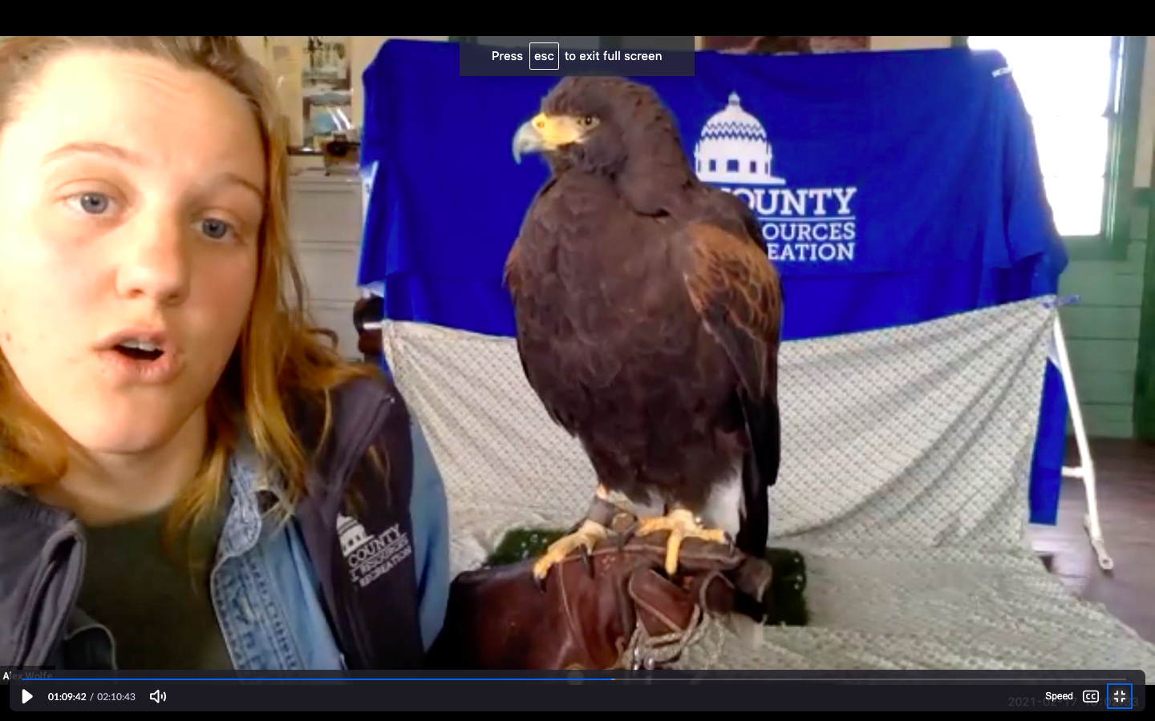

Vocabulary |  |  | Materials
- Cross pollination: the transfer of pollen from the flower of one plant to the flower of a plant having a different genetic makeup  - Self pollination: the pollination of a flower by pollen from the same flower or from another flower on the same plant. |  |  | Presentation:  - https://biodiversityproject.arizona.edu/sites/default/files/self%20pollination%20and%20cross%20pollination.pptx
Seasonality: (If more specificity is required, please note date/time range under the season)

Monsoons  July-Sept. | Autumn  Oct.-Nov. | Winter  Dec.- Feb. |  | Spring  Mar.-Apr. | Dry Summer  May-June
Guiding Questions:

5E Steps | Teacher Strategies | Student Behavior
Engagement/Introductory Activity:  This is what you will do to get the students engaged in and excited about the topic of the lesson! It should also provide an opportunity for you to get an idea of what they do (and do not) already know, and the assumptions that they have going into the lesson. | - Introduce Alex Wolfe as the scientist of the week. They are an environmental educator for Pima County, and have worked at different places like the Sonoran Desert Museum, and Reid Park Zoo.  - Ask students: Would you be interested in a job similar to this? What two jobs would you combine to be one?  - Show ‘Blob Tree’ image and ask students to type in the chat or unmute their mic to discuss which blob they are feeling like today!  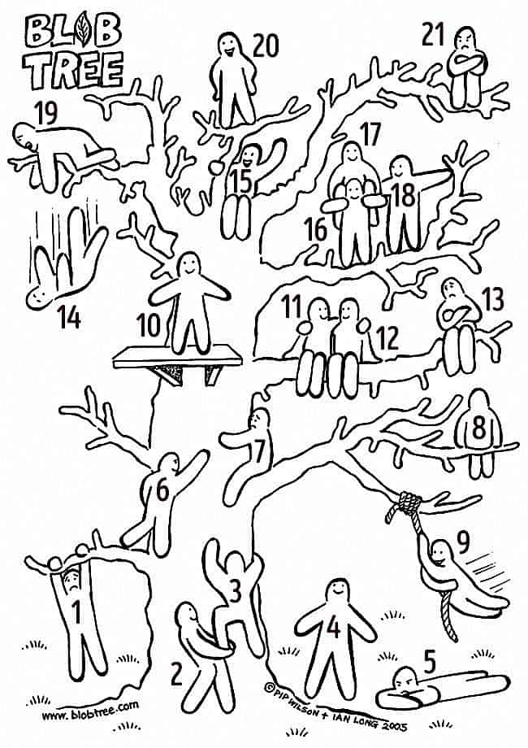 | - Students will unmute their mic or type in the chat to discuss whether Alex’s job interests them, combining education and environmental science.  - Students will answer what two jobs they think could be combined into one and explain why that would be helpful.  - Students will unmute their mic or type in the chat to answer what blob they feel like.
Exploratory Activity:  Provide step-by-step instructions on what the teacher and students will do in this activity to gain new skills and/or knowledge. Attach worksheets, PowerPoints, video links, or other material used to this section. | - Review slide on anatomy of the plant  - Zoom bomb about parts of plant involved in pollination  - Peardeck infer the definition from the picture  https://byjus.com/biology/difference-between-cross-pollination-and-self-pollination/ | - Students will review anatomy of the plant.  - Students will use zoom chat feature to “zoom bomb” the parts of the plant that invovle pollination. (Stigma, anther, pollen)  - Students will unmute themselves to infer/predict what self-pollinatinon and cross pollination are based of the name alone. They can unmute themselves or put it in the chat.
Explain:  What questions or prompts will you use to get students to explain their observations or to explain what the outcomes of the activity that they participated in were? This should provide an opportunity for students to communicate their new understandings, as well as to articulate what they still do not understand. | - Give definition  - Peardeck fill in the blank worksheet  1.Pollen grains fall off a stamen and land on a pistil of the same plant. ____________  2.Pollen from the stamen of one flower gets stuck on the legs of a bee. The bee then lands on the pistil of a different flower on the same plant. ____________  3.Pollen from one flower is carried by the wind to a flower on another plant with different DNA. ____________  4.Water carries pollen from the stamens of one plan to the pistils of another plant. ____________  Awners: 1,2, & 4 self pollination 3 cross pollination  - After students complete the fill in the blank we will request student volunteers and review the awnser  https://www.teachervision.com/seeds-pollination/activity-investigating-self-cross-pollination | - After learning the definition and details about self-pollination and cross-pollination, students will have a fill in the blank activity with a word bank.  - They each will be given 30 seconds to 1 mintue to place the word bank questions in the fill in the bank  - Students will volunteer to share their answers as we go over it as a class
Extension Activity/Questions:  This section provides an opportunity for students to connect the knowledge that they have gained to other contexts – can they take what they learned and logically expand upon it, or apply it to alternate situations? Provide one or two additional ideas for activities that students can use to expand upon the new knowledge that they have gained. | - We will explain how students can apply self pollination and cross pollination to their every day lives by showing its relation to group work  “Explaining to students that you do this everyday in group work vs working alone. You share information with each other which helps share ideas much like cross pollination. When you work alone you produce ideas (ie pollinate) by yourself ie self pollination.”  - The class will create a venn diagram to show the similarities and differnces in self pollinaton and cross pollination  - We will go over some of the venn diagrams studnets created to make a class venn diagram from studen | - Students will be given 1-2 mintues to fill in their venn diagram  - Students will volunteer to share their sections
Evaluation Activity:  How will you evaluate whether or not the students have achieved the learning objective(s) of the lesson? | - We will have a peardeck game -true or false game.  - We will go over the answer after students have responded and have small discussionon teh correct answer  - Self-pollination: When pollen from the stamen of one flower lands on the stamen of another flower on the same plant.  Awnser: False PISTIL on the same plant  Cross-pollination would take place between flowers with different DNA.  Answer: true  Petals function to attract pollinators to flowers, but are not directly involved with the process of pollination.  Awnser: true | - Students will have to place their guess in whether the statmentt is true or false  - Students will voluteer to share what they think the answer is

