The Bio/Diversity Project
Lesson Title: Plant and Pollinator Adaptations

Teacher: Rachel Morris and Shelbi Gowin
Grade Level: 7th
Time: 45 minutes

Adapted from: https://www.calacademy.org/educators/lesson-plans/flowers-seeking-pollinators
https://wise.arizona.edu/sites/default/files/FlowersSeekingPollinators_DataSheet.pdf

AZ State Science Standard: | - 7.L1U1.11  Construct an explanation for how organisms maintain internal stability and evaluate the effect of the external factors on organisms’ internal stability.
Learning Objective: | - Students will be able to explain different adaptations found in pollinators and flowers  - Students will be able to identify reasons as to why certain adaptations attract different pollinators
Language Objective: (Optional) | NA
Scientist of the Week: | Christina Grozinger  Born in Montreal, Canada  Professor of Entomology at Penn State in Pennsylvania  - Entomology: study of insects  - Areas of expertise: POLLINATORS!  Dr. Grozinger is in charge of the Grozinger Lab that studies different types of pollinators, their behaviors, health, and more! She also works for the Center for Pollination Research at U Penn on various projects. One is the Bug of the Month!  https://ento.psu.edu/research/centers/pollinators/bug-of-the-month/botmfeb2021.pdf  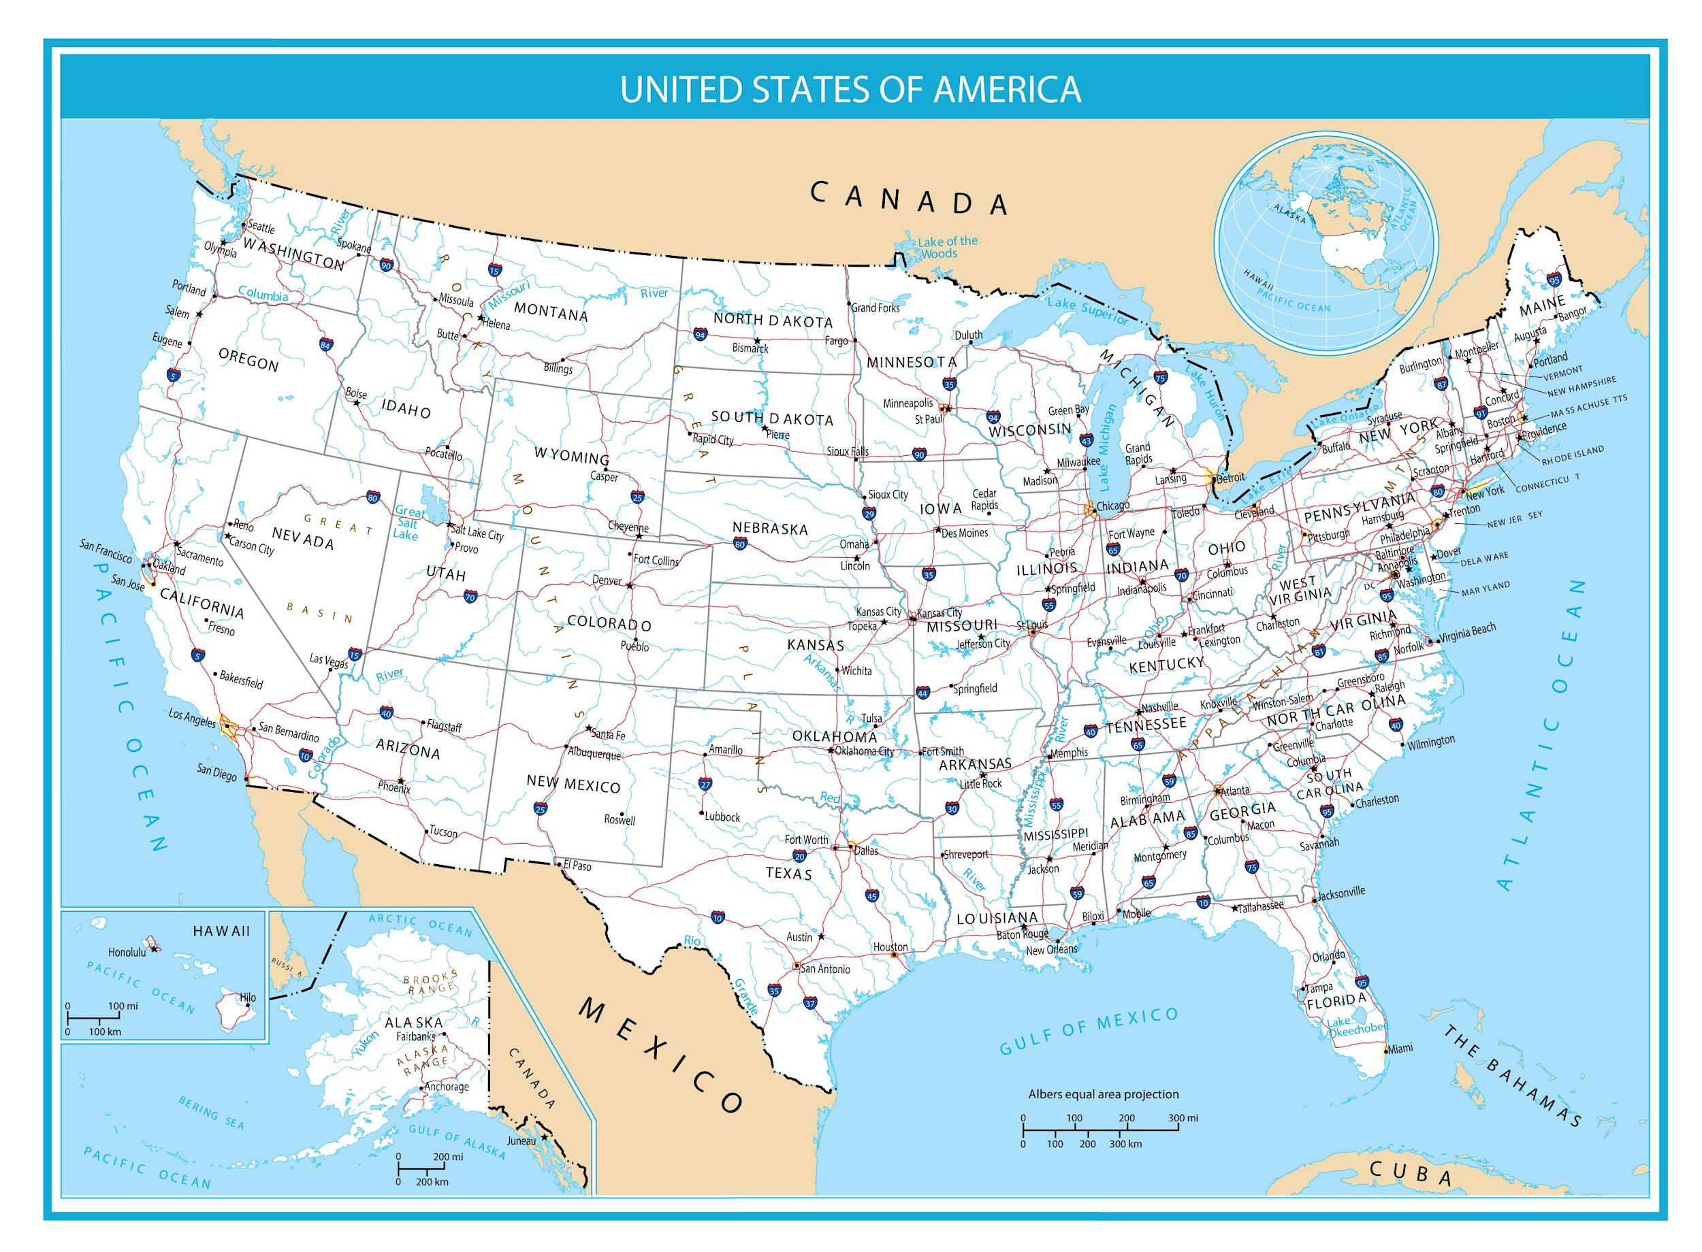

Vocabulary |  |  | Materials
- olfactory: relates to sense of smell  - adaptation: a change that an organism or species makes to be better suited to its environment |  |  | - Bug of the Month:  https://ento.psu.edu/research/centers/pollinators/bug-of-the-month/botmfeb2021.pdf  - Kahoot  https://create.kahoot.it/share/pollinator-adaptations/00486834-826b-41c2-854e-9f8359a88f19  - Slides:  https://biodiversityproject.arizona.edu/sites/default/files/Lesson%203%20_0.pptx
Seasonality: (If more specificity is required, please note date/time range under the season)

Highlight which season(s) your lesson would be most suited to. When working with the natural world, it is important to keep this in mind for your planning! Some activities are possible for a brief window of time while others may be appropriate during any time of year.

Monsoons  July-Sept. | Autumn  Oct.-Nov. | Winter  Dec.- Feb. |  | Spring  Mar.-Apr. | Dry Summer  May-June
Guiding Questions:
- Why are there different types of flowers/pollinators?
- Why do plants have flowers?
- Are all flowers attracting the same pollinators?

5E Steps | Teacher Strategies | Student Behavior
Engagement/Introductory Activity:  This is what you will do to get the students engaged in and excited about the topic of the lesson! It should also provide an opportunity for you to get an idea of what they do (and do not) already know, and the assumptions that they have going into the lesson. | - Answer students' questions from last week about who is attracted to fruity smelling flowers: Sweet scents attract daytime pollinators such as bees, butterflies and flies. When the flower is ready for pollination, their scent is the strongest; it diminishes as the flower's need for pollination declines.  - Present Dr. Christina Grozinger as a professor of entomology as the scientist of the week  - Describe her research area and show the “Bug of the Month” campaign launched by the Center of Pollination Research that she is a part of  - https://ento.psu.edu/research/centers/pollinators/bug-of-the-month/botmfeb2021.pdf  - This bug uses mimicry-a type of adaptation-to be like a bumble bee  - Prompt the question: Are flowers trying to win a beauty contest?  - Encourage students to think about size, shape, smell, and color of the flower. | - Students will observe the bug of the month and infer how the Bumblebee mimic- Laphria flavicollis uses mimicry to survive  - Students will unmute their mic or type in the chat to discuss whether they believe flowers are trying to win a beauty contest and what this means in terms of pollination.  - The more “beautiful”= the more pollinators are attracted to them
Exploratory Activity:  Provide step-by-step instructions on what the teacher and students will do in this activity to gain new skills and/or knowledge. Attach worksheets, PowerPoints, video links, or other material used to this section. | - “Pollinator profile cards” will be shown for moths and bats with information regarding when pollination occurs, how they pollinate, what flowers they are attracted to, and a fun fact.  - Ask students to identify the adaptations shown on the cards  - ex. Bats visit flowers during the night time.  - “during the night time” is the adaptation- nocturnal  - ex. Moths have long mouths to reach inside flowers  - “long mouths” is the adaptation  - ex. Butterflies have a good sense of sight but a bad sense of smell  - “good sight” is the adaptation  - ex. Bees are attracted to sweet smelling flowers  - “attracted to good smells” is the adaptation  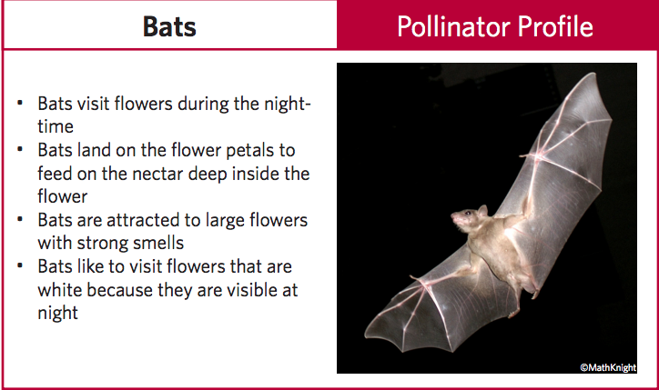  (example of a pollinator card)  - Discuss how each adaptation helps the animal successfully complete pollination  - ex. Bats visiting flowers at night helps them avoid predators during the day. | - Students will unmute their mic or type in the chat to identify phrases in each sentence that are attributable to a pollinator’s adaptation  - Students will unmute their mic or type in the chat to explain how this adaptation will help the pollinator survive
Explain:  What questions or prompts will you use to get students to explain their observations or to explain what the outcomes of the activity that they participated in were? This should provide an opportunity for students to communicate their new understandings, as well as to articulate what they still do not understand. | - Present slides with flower data (different traits) and the pollinators that are most attracted to that flower.  - First give the slide with the flower data, discuss the pros and cons of the different traits and then show a slide that has the pollinators that are attracted to it.  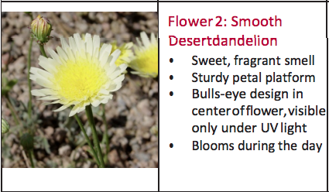  (example of first slide)  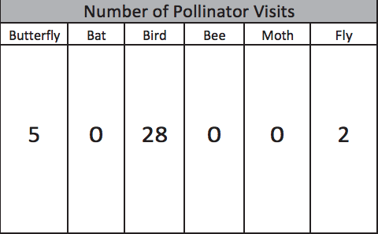  (example of coordinating slide)  - Ask students to infer why certain pollinators may be attracted to their flower given the traits.  - Olfactory (smell), attractiveness, and shape will be presented as different types of adaptations that flowers have to suit the needs of a specific type of pollinator.  - ex. flowers with small petals and long shapes attract birds because their beak can reach in to pollinate and they do not sit on the flower while they pollinate. | - Students will observe and discuss, by unmuting their mic or typing in the chat, different traits that each flower has, its pros and cons, and make an educated guess as to which pollinator will be attracted to that flower  - Students will compare their guess with the corresponding slide that shows the number of pollinator visits each pollinator made to that flower.  - Students will eventually be asked to identify their pollinator match without guidance from the presenters after a couple practice rounds.
Extension Activity/Questions:  This section provides an opportunity for students to connect the knowledge that they have gained to other contexts – can they take what they learned and logically expand upon it, or apply it to alternate situations? Provide one or two additional ideas for activities that students can use to expand upon the new knowledge that they have gained. | - Present a peardeck activity with the prompt: Draw a unique flower that has an adaptation to suit a specific pollinator of your choice.  - Give the following example if students get stuck: a flower that has a strong scent and white petals to be seen at night-- this flower will attract a moth | - Students will identify a pollinator of their choice, taking into consideration its adaptations and what flowers they are attracted to to design their own flower that will specifically attract that pollinator to it.
Evaluation Activity:  How will you evaluate whether or not the students have achieved the learning objective(s) of the lesson? | - For our wrap up, we will be playing Kahoot.  - Have a slide showing our goals/objectives for the day again (shown at the beginning of class).  - Remind students to be thinking about these goals and apply what they learned during the class period while playing kahoot.  - Kahoot will consist of 5 questions that will be based on our guiding questions, goals, and material presented to accurately gauge our students' understanding.  - What sense does the word “olfactory” refer to?  - Why would a hummingbird be attracted to a flower with a long tube, but not a bee?  - Moths are not pollinators, Hawks are pollinators (T/F)  - One adaptation that bats have made to make pollination easier is:  - If you were a pollinator what adaptation would you want to help you pollinate? | - Students will be prompted of the directions for the activity to follow (kahoot)  - Kahoot: https://create.kahoot.it/share/pollinator-adaptations/00486834-826b-41c2-854e-9f8359a88f19  - Student will be reviewing the goals of the day as they are entering kahoot

