The Bio/Diversity Project
Lesson Title: Plant Adaptations and Pollinators

Teacher: Ms. Gricelda Meraz
Grade Level: 6th
Time: 30 minutes +10 minute introduction

Adapted from: https://www.calacademy.org/educators/lesson-plans/flowers-seeking-pollinators

AZ State Science Standard: | 6.L2U1.13:  - Develop and use models to demonstrate the interdependence of organisms and their environment including biotic and abiotic factors.
Learning Objective: | In student friendly language, write your objective. Your objective is likely to target just one or two aspects of the Science Standard, as mastery of a Standard usually takes multiple lessons. A Science Standard should be broken down into smaller, more manageable objectives per lesson.  For example:  - Students will compare and contrast different flower features.  - Students will describe how each flower feature attracts a different pollinator.  - Students will explain the difference between biotic and abiotic pollination.
Language Objective: (Optional) | N/A
Scientist of the Week: | 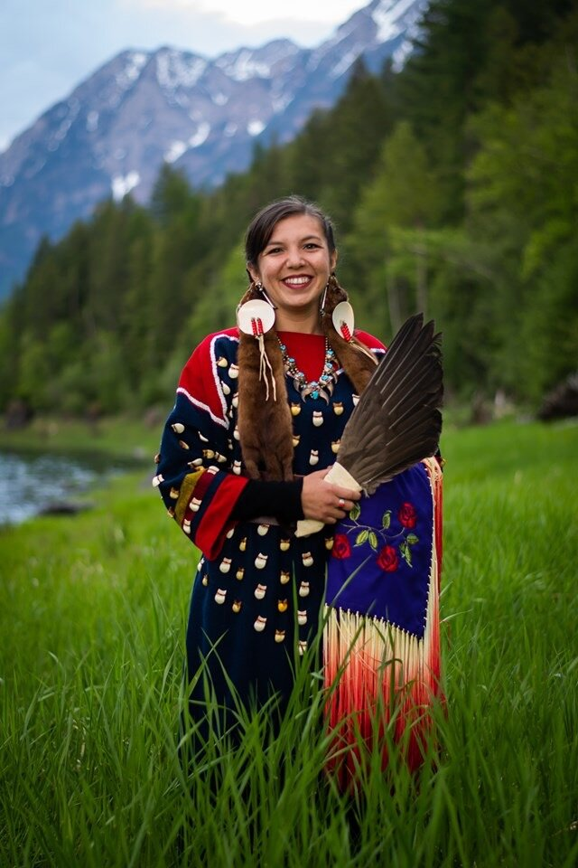  - Rose Bear Don’t Walk  - She seeks to bridge science, culture and health through her work with traditional Indigenous foods and native plants of northwest Montana  - A descendant of the Bitterroot Salish and Crow tribes of the Montana area  - She is an ethnobotanist  - the study of a region's plants and their practical uses through the traditional knowledge of a local culture and people  Rose Bear Don't Walk

Vocabulary |  |  | Materials
Provide a bulleted, alphabetized list of words that students will hear, speak, write, and/or read about in the lesson. Please do not list more than 4-5 words. These words must be integral to developing content understanding. You may copy and paste these directly from the Scope and Sequence Guide document.  - Abiotic- nonliving parts of an ecosystem or environment  - Biotic- living parts of an ecosystem or environment  - Pollen- Pollen is a fine powder produced by certain plants when they reproduce |  |  | Provide a bulleted and hyperlinked list of relevant materials for the lesson.  - Flowers Seeking Pollinators  - Polinizador en Busca de Flores  - YouTube video:  - Plant Pollination  - La polinización de las plantas
Seasonality: (If more specificity is required, please note date/time range under the season)

Highlight which season(s) your lesson would be most suited to. When working with the natural world, it is important to keep this in mind for your planning! Some activities are possible for a brief window of time while others may be appropriate during any time of year.

Monsoons  July-Sept. | Autumn  Oct.-Nov. | Winter  Dec.- Feb. |  | Spring  Mar.-Apr. | Dry Summer  May-June
Guiding Questions:

Write down bulleted, guiding questions that you will ask students in order to promote a deeper understanding of the subject matter. These are questions you will ask students to open the conversation on this topic. You may copy and paste these directly from the Scope and Sequence Guide document.

For example:

- How do flowers attract different pollinators?
- What pollination strategies have flowers developed to survive?

5E Steps | Teacher Strategies | Student Behavior
Engagement/Introductory Activity:  This is what you will do to get the students engaged in and excited about the topic of the lesson! It should also provide an opportunity for you to get an idea of what they do (and do not) already know, and the assumptions that they have going into the lesson.  Maya | Presentation: Flowers Seeking Pollinators  Polinizador en Busca de Flores  Teachers will prompt students with a couple of questions:  - What is your favorite flower?  - Why do plants have flowers?  Teachers will play a video that gives a quick introduction on plants that are adapted to different forms of pollination  Plant Pollination  La polinización de las plantas | Students will respond to the questions and watch the short video about plant adaptations and pollinators.
Exploratory Activity:  Provide step-by-step instructions on what the teacher and students will do in this activity to gain new skills and/or knowledge. Attach worksheets, PowerPoints, video links, or other material used to this section. | The teachers will introduce specific adaptations pertaining to desert plants.  Using powerpoint slides, give definition of specific adaptations and show adaptations through images and diagrams  - Stomata: Tiny openings present on the epidermis of the plant leaves, play a role in gaseous exchange and photosynthesis.  - Leaves: help produce food and energy of the plants, sometimes a waxy, thick covering for keeping water inside cacti  - Shallow Widespread roots: Roots that allow the absorption of water through extensive underground roots.  - flower color and pollinators they attract  Provide images of various sonoran desert plants and their adaptations. | Students will be asked to pay attention to the slides and the teachers.  Ask questions when needed and answers the intern teachers questions  - Why is abiotic pollination important to plants?  Pay attention to plants and describe their adaptations
Explain:  What questions or prompts will you use to get students to explain their observations or to explain what the outcomes of the activity that they participated in were? This should provide an opportunity for students to communicate their new understandings, as well as to articulate what they still do not understand. | Interns will present the differences and similarities between abiotic and biotic pollination  After, the interns will ask the students to participate in the venn diagram activity through a discussion and a group answered venn diagram. | Students will participate in the venn diagram activity  - first-they will pay attention to the abiotic and biotic slides and understand the differences  - then- they will be told of the venn diagram activity where the interns will write down their responses in a screen shared venn diagram for the whole class
Extension Activity/Questions:  This section provides an opportunity for students to connect the knowledge that they have gained to other contexts – can they take what they learned and logically expand upon it, or apply it to alternate situations? Provide one or two additional ideas for activities that students can use to expand upon the new knowledge that they have gained.  Maya | Plant Medicine!  Interns will ask students if they use any Sonoran Desert plants as food or medicine  Interns will present information about indigenous plant medical knowledge:  Now that we know a little bit more about the relationship between plants and pollinators, let's talk about the relationship between humans and some flowering plants.  - Prickly pear fruit  - Agave- agave roasts  - Nopales- decreases blood sugar  - Aloe vera- burns and irritation | Students will listen and share their experiences with desert plants as food or medicine. They will then listen to the interns describe some different plant food sources of the Tohono O'odham and other Indiigenous groups in the Southwest.
Evaluation Activity:  How will you evaluate whether or not the students have achieved the learning objective(s) of the lesson?  Maya | Interns will design a matching game that will get students to match different plants with their respective pollinators.  Ex: Hummingbird trumpet and hummingbird  Desert marigold and bees  Pines and wind | Students will match each correct pair as a fun ending activity.

