The Bio/Diversity Project
Lesson Title: Biodiversity Decline: Climate Change and Invasive Species

Teacher: Emily Burke + Victoria Howard
Grade Level: 6th
Time: 1 hour

Adapted from: https://betterlesson.com/lesson/639878/invasive-species

AZ State Science Standard: | 6.L2U3.11  - Use evidence to construct an argument regarding the impact of human activities on the environment and how they positively and negatively affect the competition for energy and resources in ecosystems.
Learning Objective: | - Students will be able to explain what an invasive species is and recognize at least 1 example of invasives in the Sonoran Desert  - Students will be able to articulate the human impact of biodiversity decline in the Sonoran Desert  - Students will be able to describe the importance of conservation efforts against biodiversity loss
Language Objective: (Optional) | N/A
Scientist of the Week: | 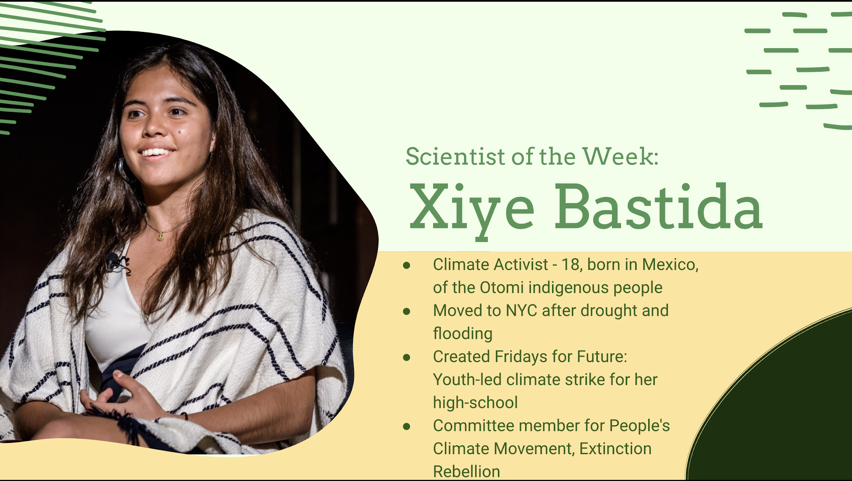

Vocabulary |  |  | Materials
- Biodiversity Decline  - Invasive Species  - Climate Change  - Conservation |  |  | - Google Slides  - Reid Park Virtual Tour  - Invasive Species Video
Seasonality: (If more specificity is required, please note date/time range under the season)

Highlight which season(s) your lesson would be most suited to. When working with the natural world, it is important to keep this in mind for your planning! Some activities are possible for a brief window of time while others may be appropriate during any time of year.

Monsoons  July-Sept. | Autumn  Oct.-Nov. | Winter  Dec.- Feb. |  | Spring  Mar.-Apr. | Dry Summer  May-June
Guiding Questions:

- What are the costs of biodiversity loss?
- What is the effect of climate change on biodiversity decline?
- What are invasive species, why are they a problem, and what can be done about them?
- What is the importance of interactions between invasive, non-native, endangered, rare, and native species?
- What role do humans play in the management of invasive species?

5E Steps | Teacher Strategies | Student Behavior
Engagement/Introductory Activity:  This is what you will do to get the students engaged in and excited about the topic of the lesson! It should also provide an opportunity for you to get an idea of what they do (and do not) already know, and the assumptions that they have going into the lesson.  ~15 mins | Introduce the scientist of the week - Xiye Bastida  Ask students to send a penguin emoji in the chat if they have ever visited the Reid Park Zoo in Tucson.  Show a video of a virtual tour of Reid Park Zoo, which also explains how climate change impacts multiple species.  Explain how Reid Park Zoo helps facilitate animal conservation by showing examples of animals in the park:  - African Elephants - hunted for their ivory tusks  - Giant Anteaters - often killed by cars in Brazil - Anteater highway project  - White Rhino Yobunga - also hunted for horns - Tarangire Elephant project  - Reid Park’s local partners also rehabilitate injured native wildlife | Students will send a penguin emoji in the chat if they have ever visited the Reid Park Zoo.  Watch a virtual tour from Reid Park Zoo and learn how climate change affects organisms.  Students will learn how Reid Park contributes to wildlife conservation for African Elephants, Giant Anteaters, White Rhinos, and local wildlife.
Exploratory Activity:  Provide step-by-step instructions on what the teacher and students will do in this activity to gain new skills and/or knowledge. Attach worksheets, PowerPoints, video links, or other material used to this section.  ~10 mins | Elaborate on why zoos are important by defining biodiversity decline - the decrease or loss of living organisms, and by showing a line-graph of biodiversity from 1970-2016  - Explain that there are five causes of biodiversity decline: climate change, invasive species, habitat loss, pollution, and overuse of resources.  Use a world map to show where the mentioned Reid Park Zoo animals naturally live. Explain that they are “non-native” as they came from somewhere else.  Show a video introducing the concept of an invasive species:  https://www.youtube.com/watch?v=PRmdzi-smoY&feature=emb_logo  - Ask students to type in the Microsoft Teams Whiteboard what they think an invasive species is, what they do, why they are bad, or other thoughts. | Students will learn the definition of biodiversity decline. They will see how scientists measure this decline by viewing a line-graph of biodiversity from 1970-2016.  Students will learn the five main causes of biodiversity decline.  Students will see where the Reid Park Zoo animals naturally live on a world map, and understand this is why they are considered non-native  Students will watch a video introducing the concept of an invasive species. Students will type in the Microsoft Teams Whiteboard what they think the term invasive species means, what invasive species do, why they are bad, etc.
Explain:  What questions or prompts will you use to get students to explain their observations or to explain what the outcomes of the activity that they participated in were? This should provide an opportunity for students to communicate their new understandings, as well as to articulate what they still do not understand.  ~10 mins | - Explain what an invasive species is: an undesirable, harmful, and rapidly spreading plant that is non-native and harms local ecosystems.  - Present three examples of invasive species in the Sonoran Desert, where they came from, and why they pose a threat:  - Buffelgrass - introduced 1930s for cattle feed and soil erosion, spreads on highways. Causes increased fires, outcompetes plants.  - Giant Reeds - ornamental, brought in 1800s to LA, in Sabino Canyon. Causes increased fires, grows rapidly and outcompetes plants for water.  - Argentine Cactus Moth - Accidentally brought to Florida in 1900s, eats prickly pear and devastates their populations | Receive a formal definition of an invasive species and learn about 3 different invasive species currently threatening the Sonoran Desert: Buffelgrass, Giant Reeds, and the Argentine Cactus moth, and why they pose a threat
Extension Activity/Questions:  This section provides an opportunity for students to connect the knowledge that they have gained to other contexts – can they take what they learned and logically expand upon it, or apply it to alternate situations? Provide one or two additional ideas for activities that students can use to expand upon the new knowledge that they have gained.  ~15 minutes | - Describe how conservation can be approached from multiple levels  - Direct action  - Research  - Policy  - Activism  - Interaction of the multiple levels is what allows conservation efforts to be successful  - Provide examples of local conservation efforts  - Wildlife crossing on Oracle Road  - Improves habitat connectivity between habitat patched disconnected by Oracle Rd.  - Prevents roadkill on a major highway  - Dozens of species spotted using it since its creation in 2016  - Bat bridge on Ina Road  - The Ina bridge provides important roosting habitat for 15,000 Mexican free-tailed bats and Cave myotis.  - The replacement bridge would remove the habitat  - Bat Boxes were introduced to mitigate the loss | Students will reflect on how different aspects of conservation efforts interact by either raising their hand or typing in chat what happens when one level of conservation falters  Students will examine examples of conservation efforts in the Sonoran Desert in the form of urban habitat and wildlife crossings.
Evaluation Activity:  How will you evaluate whether or not the students have achieved the learning objective(s) of the lesson?  ~5 minutes | Find that Buffelgrass! Activity  - Use three images of buffelgrass to test the students’ grass identifying abilities.  - Images include both green and dry buffelgrass in different habitats  - Explain that field ID skills of invasives translates beyond the classroom | Students will be tasked with identifying where buffelgrass is found in different images  Students will raise their hands and describe where in the image the grass is seen.

