The Bio/Diversity Project
Lesson Title: Introduction to Biodiversity

Teacher: Emily Burke and Victoria Howard
Grade Level: 6th
Time: 45 minutes + 5-10 minute pre-assignment

Adapted from: https://education.eol.org/lesson_plans/6-8_ScienceSkills_BioblitzSkillbuilder3.pdf

AZ State Science Standard: | 6.L2U1.13  - Develop and use models to demonstrate the interdependence of organisms and their environment including biotic and abiotic factors.
Learning Objective: | - Students will be able to recognize the difference between abiotic and biotic factors  - Students will be able to describe Sonoran Desert biodiversity and know at least 3 plant and animal species inhabiting the Sonoran Desert  - Students will be able to articulate why maintaining biodiversity is critical to a healthy habitat
Language Objective: (Optional) | N/A
Scientist of the Week: | 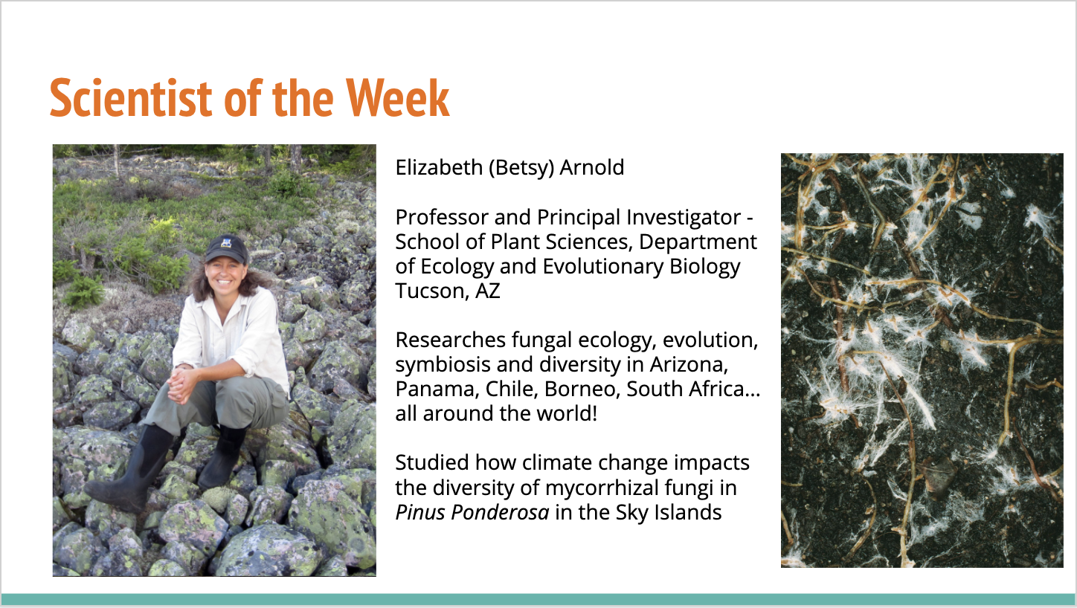

Vocabulary |  |  | Materials
- Biodiversity  - Community  - Ecosystem  - Species  - Niche |  |  | - Youtube Video  - Slides
Seasonality: (If more specificity is required, please note date/time range under the season)

Highlight which season(s) your lesson would be most suited to. When working with the natural world, it is important to keep this in mind for your planning! Some activities are possible for a brief window of time while others may be appropriate during any time of year.

Monsoons  July-Sept. | Autumn  Oct.-Nov. | Winter  Dec.- Feb. |  | Spring  Mar.-Apr. | Dry Summer  May-June
Guiding Questions:

- What makes the Sonoran Desert unique compared to other deserts in the world?
- What does biodiversity look like on a macro and micro scale?
- What kind of scientists study biodiversity?

5E Steps | Teacher Strategies | Student Behavior
Engagement/Introductory Activity:  This is what you will do to get the students engaged in and excited about the topic of the lesson! It should also provide an opportunity for you to get an idea of what they do (and do not) already know, and the assumptions that they have going into the lesson.  ~5 mins | For bellwork, we will have students watch the video “A Day in the Desert” and ask them to write down all animals they recognize.  https://www.youtube.com/watch?v=xWM0hYyHDvQ&amp;t=137s  Afterwards, we will ask the students, “Who think they wrote down the most animals? How many did you have? What were they?”  Then we will ask students to type in the chat how many mammals, reptiles, birds, and plants they each saw (one at a time). | For bellwork, students will watch the video “A Day in the Desert” and write down all of the different organisms that they recognize on a piece of paper. Students will participate in a brief discussion to see which of their peers wrote down the most animals, and what those were.
Exploratory Activity:  Provide step-by-step instructions on what the teacher and students will do in this activity to gain new skills and/or knowledge. Attach worksheets, PowerPoints, video links, or other material used to this section.  ~10 mins | A slide will be shown representing each of four organism groups: mammals, reptiles, birds, and plants. We will ask students to type in the chat how many of each of these types of animals they observed, and what those were.  Afterwards, we will hold a brief discussion about their results:  -Which group of animals was seen the most?  -Which group was seen the least?  -Are there types of organisms that we didn’t see at all? | Students will be shown a slide representing each of four organism groups. Students will use their bellwork lists to type in the chat how many individuals of each group they observed, and what their names were.  Afterwards, students will engage in a brief discussion to identify patterns in their data. They will identify which groups were seen the most, seen the least, and not seen at all.
Explain:  What questions or prompts will you use to get students to explain their observations or to explain what the outcomes of the activity that they participated in were? This should provide an opportunity for students to communicate their new understandings, as well as to articulate what they still do not understand.  ~25 mins | We will present the Google Slides presentation to:  -Introduce the scientist of the week (and share our brief personal experience working with them)  -Connect the Exploratory Activity to real life science by briefly explaining taxonomy (to the level 6th grade honor students)  -Define biodiversity and break down the elements of ecosystems (organism, population, community, ecosystem, biosphere)  -Introduce what a ‘niche’ means, using a food web and questions to develop understanding - we will ask, “What would happen if we took away the mouse? The plants?”  We will relate the idea of a niche directly to student lives - “What are the hobbies, activities, etc. that define their niche?”  -Illustrate why the diversity within the Sonoran Desert is unique  We will ask for student questions between topics. | Students will watch a Google Slides presentation that will be used to introduce and explain Sonoran Desert Biodiversity. Students are encouraged not to directly take notes on the material.  Students will also be introduced to the scientist of the week, a local scientist from Tucson.  Students will learn how scientists use taxonomic classifications to group organisms, what biodiversity means, the components of ecosystems, what a ‘niche’ is, and how the Sonoran Desert is a unique and diverse ecosystem itself.
Extension Activity/Questions:  This section provides an opportunity for students to connect the knowledge that they have gained to other contexts – can they take what they learned and logically expand upon it, or apply it to alternate situations? Provide one or two additional ideas for activities that students can use to expand upon the new knowledge that they have gained.  ~15 mins | On a PowerPoint slide, students will be asked to estimate the number of species of mammals, birds, plants, insects and reptiles on Earth and in the Sonoran Desert. After sharing their estimations, the current scientific consensus will be revealed to the students.  Questions to ask:  - Do you think all species have been discovered?  - What makes certain groups more difficult to find and identify?  - Why is it important for scientists to try to discover all species? | Students will type in chat their guess for the number of species of mammals, birds, plants, insects, and reptiles on Earth and in the Sonoran Desert.  The class will discuss the knowns and unknowns of biodiversity (following the questions listed at the left) and why scientists estimate the actual totals.
Evaluation Activity:  How will you evaluate whether or not the students have achieved the learning objective(s) of the lesson?  ~2 mins | As a final activity, students will be tasked with coming up with a definition of biodiversity based on the previous discussion. | Individually, students will type in the chat their definition of biodiversity using the knowledge they have gained throughout the lesson.

