Bio/Diversity Project
Lesson Title: Insects of the Sonoran Desert

Teacher: Gricelda Meraz
Grade Level: 6th
Time: 80 minutes

AZ State Science Standard: | 8.L3U3.10  - Communicate how advancements in technology have furthered the field of genetic research and use evidence to support an argument about the positive and negative effects of genetic research on human lives.
Content Objective:  Math, Reading, Science, Writing, Other: | - Students will create their own insect with adaptations suited to the sonoran desert  - Students will be able to identify the common structure and characteristics of insects  - Students will understand the significance of insects to humans and the ecosystem
Language Objective: (Optional) | N/A
Scientist of the Week: | - Rodolfo Neri Vela  - He is the first Mexican, and the second Latin American to have traveled to space.  - He is currently a professor in the electrical engineering division, at the National Autonomous University of Mexico  - Mexican scientist and astronaut who flew aboard a NASA Space Shuttle mission in the year 1985.

Vocabulary |  |  | Materials
- Abdomen  - Antennae  - Exoskeleton  - Head  - Insect  - Thorax |  |  | - Print insect Diagram  - Play-doh  - Habitat cards
Seasonality:No specific seasonality required
Monsoons  July-Sept. | Autumn  Oct.-Nov. | Winter  Dec.- Feb. |  | Spring  Mar.-Apr. | Dry Summer  May-June
Guiding Questions:

- What makes an insect different from other arthropods?
- What is an insect?
- What impacts do insects have on humans?
- What role do insects play in the ecosystem?
- How can there be so many similarities among living things, yet so many different species of plants and animals?

Engagement/Introductory Activity:
- Begin with a presentation with basic information and exploratory questions.
- https://www.slideshare.net/lgotthar/insects-powerpoint-12238930
- Show students different arthropods, including insects, so students can try to figure out if the arthropod is an insect or not
- https://www.calacademy.org/sites/default/files/assets/docs/pdf/237_insectsarthropods_refresh.pdf

Exploratory Activity:
- Pass out one Insect Diagram handout for each student.
- Have students work in groups to try to fill out the sheets first, then have a class discussion about what each part is and what they think it does. (Try to allow students to share definitions in their own words before giving the class the formal definitions.)
- https://www.calacademy.org/sites/default/files/assets/docs/pdf/237_insectdiagram_refresh.pdf

Explain:
- The outline of the insect body is basic, but most of them fit into this outline. How do you think insects have come to be so numerous yet with the same body plan? (It is specialization due to evolution and how fast insects can reproduce.)
- With this in mind, what kind of specializations can you think of in certain insects?

Extension Activity/Questions:
- Students will put their knowledge into play by creating their own insect that is adapted specifically to the sonoran desert.
- Students will construct their insect by using clay
- Each student will be given an Invent an Insect worksheet and a habitat card. They will also be given an example of an insect that lives in that habitat
- Rules of the activity:
  - Invented insect must be suited for the habitat card they are given
  - Invented insects should be grounded in reality(ex:insects can’t fly around with jet packs) and must have the same body parts as a real insect
- https://www.calacademy.org/sites/default/files/assets/docs/pdf/237_inventaninsectsheet_redesign.pdf
- What does each part of the body specialized to do on your insect? (Use insects they know of as a way to make them realize how specialized certain body parts are) This should also allow them to relate the body parts to the insect’s diet, habitat, and way of life.
  - Head/antennas allow for sight and knowledge of their surroundings in what way; temperature, touch?
  - Mandibles for cutting, masticating, piercing?
  - What purposes do legs serve? (Movement and pollinating)
  - Wings suited for what kind of flying? Fast and accurate, lofty?
  - Thorax contains a stinger for prey or purely defense?
  - What do its legs help the insect do? Jump high, stride on water?
  - What does the color of the insect allow it to do? Warn, attract, mimic, or camouflage?

Evaluation Activity:
How will you evaluate whether or not the students have achieved the learning objective(s) of the lesson?
- In groups, have the students present their insects to each other. Talk about what role it will play in its ecosystem, and/or its role with humans (decomposer, pest control, merely food for other animals, pollinator, producer of a useful substance, parasite). How does it fill this role?

  - Abdomen: the last of an insect’s three main body parts.
  - Adaptation: any structure or behavior of an organism that improves its chances for survival
  - Antenna (pl. antennae): the thin feelers on the head of an animal like a crayfish, isopod, or insect. Antennae are used to sense the environment.
  - Arthropods: a group of animals with exoskeletons, jointed legs and segmented bodies, including insects, spiders, ticks, scorpions, centipedes, crabs and shrimp.
  - Entomologist: a scientist who studies insects
  - Exoskeleton: a hard, protective covering found in all arthropods, which provides structure like a skeleton, but is on the outside.
  - Habitat: the place or type of place where a plant or animal naturally or normally lives and grows
  - Head: the first of an insect’s three main body parts
  - Insects: a group of arthropods that is characterized by having a three-part segmented body, six legs, and two antennae, including beetles, ants, and bees.
  - Larva (pl.: larvae): the wormlike early stage in the life cycle of an insect.
  - Metamorphosis: the change of an insect (or other animal) from one form into another as it develops into an adult. Butterflies are a well-known example.
  - Thorax: the middle of an insects three body parts. An insect’s legs and wings are always attached to the thorax.

Student Articles
Name: Tarantula Hawk
Scientific Name: Pepsis formosa
Physical Description: The more familiar species are up to 5 cm long, making them among the largest of wasps, and have blue-black bodies and bright, rust-colored wings. Their long legs have hooked claws for grappling with their victims. The Stinger of a female can be up to 7 mm long, and the powerful sting is considered one of the most painful insect stings in the world.
Description of Habitat: On or in another animal These wasps are highly adaptable, capable of surviving in a wide range of habitat settings. Tarantula hawks inhabit tropical rainforests, deserts, shrub- and grasslands. Simply, they are found wherever tarantulas appear.
Species Summary: They are widely known as tarantula hawks because of their capability of hunting down tarantulas. They are one of the largest parasitoid wasps, using their sting to paralyze their prey before dragging it to a brood nest as living food; a single egg is laid on the prey, hatching to a larva which eats the still-living prey. Tarantula hawks detect chemical scents in its surroundings as they walk on forest grounds. The insect is also equipped with one centimeter long stingers. The tarantula hawk is a diurnal creature that spends the day in search of nectar and fermented fruits. However, due to the nocturnal lifestyle of the tarantulas, hunting usually occurs at dusk. The wasps are usually calm and do not attack humans unless their life is in danger.
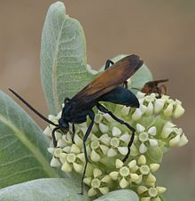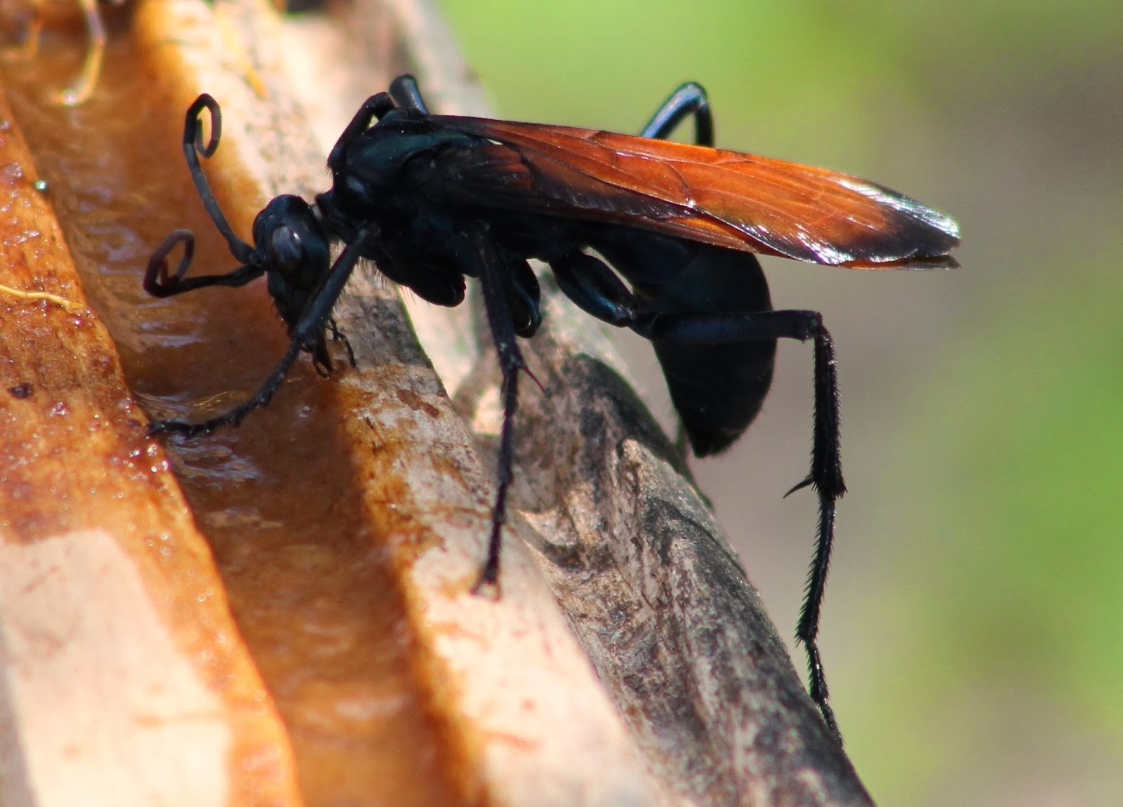

Student Articles
Name: Assassin Bug
Scientific Name: Phasmatocoris labyrinthicus
Physical Description: Labyrinth bugs have long, thin legs and look similar to stick insects. Their front legs are prickly and raptorial, like those of a praying mantis — traits that help them grasp and trap prey. Once the labyrinth bugs seize their victims, they make quick work of rendering them helpless. They also have a sharp mouthpart that they use to suck juices out of their prey. They're mostly sit-and-wait predators, but they're extremely quick once they reach out and snatch their prey. The bugs have wings but they do not seem to use them, even when provoked.
Description of Habitat: Caves Assassin bugs are found in discreet, catacomb-type recesses within Kartchner Caverns State Park, which is how the insect got its name.
Species Summary: A new species of "assassin bug" — a type of gutsy predatory insect that neutralizes prey using its thorny front legs and sharp, needlelike mouth — has been discovered deep in a limestone cave in Arizona. They live in labyrinthine parts of the cave and tend to be in areas that are very difficult, or impossible, for people to get into. Assassin bugs can be found throughout the world but are most commonly located in tropical climates. There are currently about 1,000 known species, 38 of which have been recorded in subterranean habitats and only six of which are known to be endemic in caves,
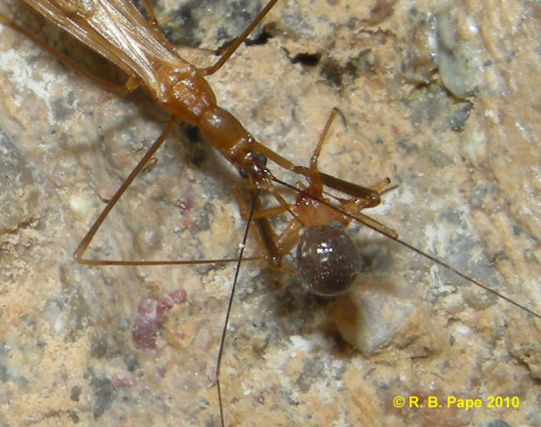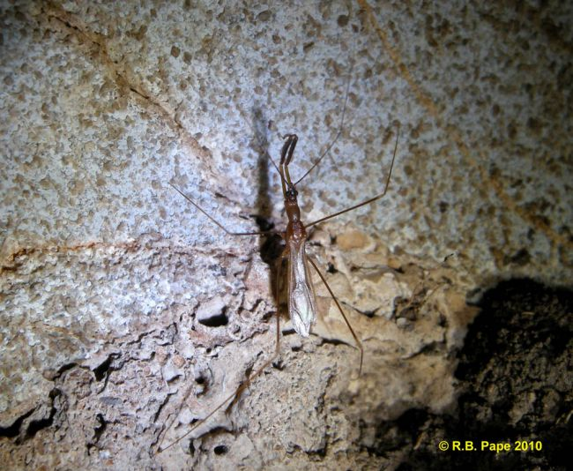

Student Articles
Name: Cochineal
Scientific Name: Dactylopius coccus
Physical Description: The adult female cochineal insect is 2 to 5 mm (0.1 to 0.2 in) long with a distinctly segmented, purplish red or carmine-colored body.
Description of Habitat: Fruit bearing
Species Summary: Cochineal insects feed on certain prickly pear cacti and are most obvious on the flat pads of the cactus in spring. They occur in colonies covered with a fluffy white wax that they secrete. they are native to desert areas of the southwestern United States. These insects also were once used to make dye, but to a much lesser extent than the South American cochineal insect.

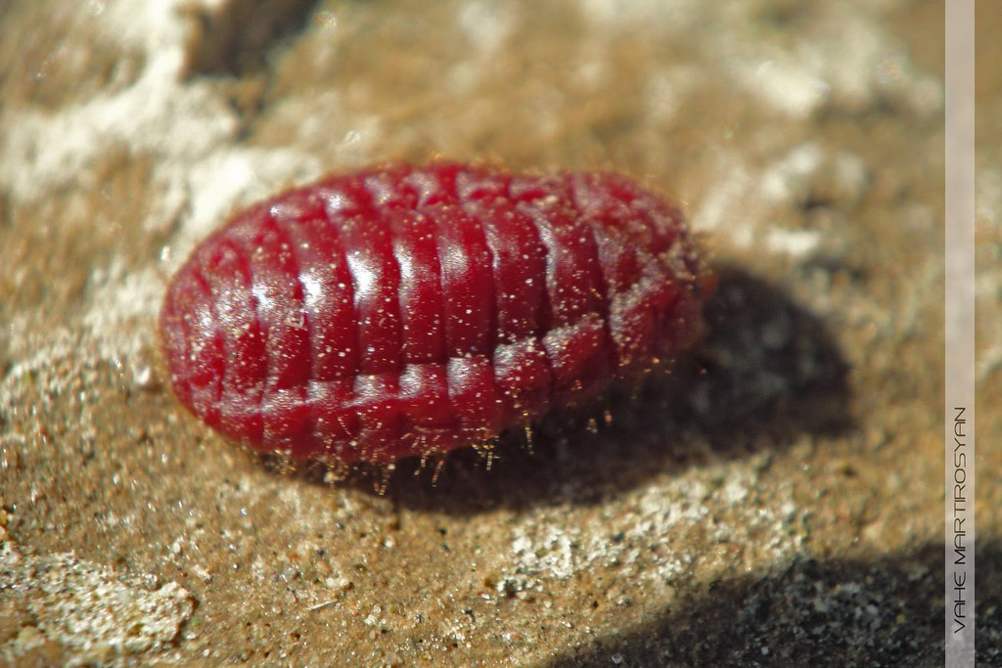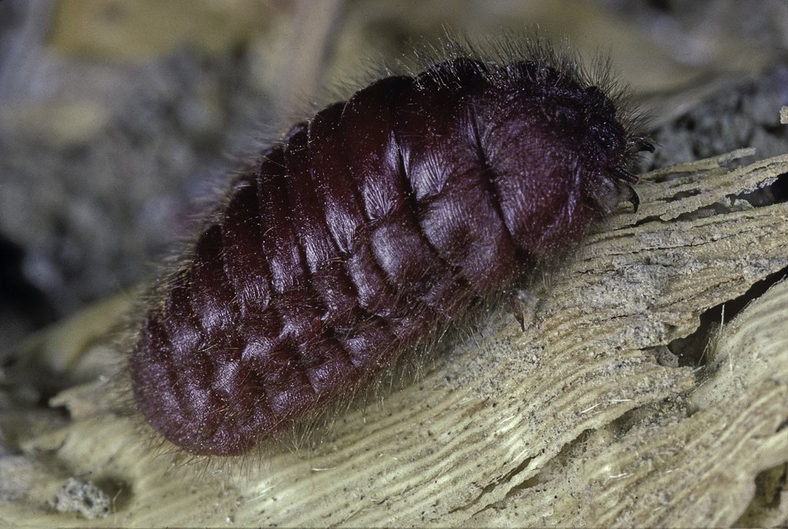

Student Articles
Name: Pinacate beetle
Scientific Name: Eleodes pimelioides
Physical Description: Wingless and usually black
Description of Habitat: Dry desert
Species Summary: These escape extreme temperatures by remaining buried in the sand during the heat of the day, where temperatures may be significantly lower. The pinacate beetles are also called clown beetles because of their defensive stance; they stand on their heads. This action precedes the release of a foul, oily fluid from repugnatorial glands located at the tip of the abdomen, a defense that repels most predators. However, the grasshopper mouse is not deterred by the beetle’s odiferous offerings. It simply grabs the beetle with its paws, forcing the tip of the abdomen into the sand, and eagerly begins to consume the tastier head and thorax, stopping just short of the ill-tasting defensive glands
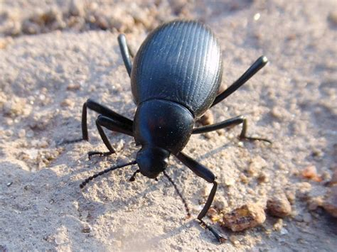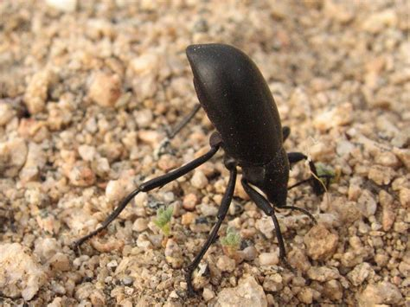

Student Articles
Name: Toe-biters
Scientific Name: Belostomatidae
Physical Description: The Giant Water Bug's body is mostly flat and oval shaped with dark brown, "dead leaf" coloring. Unable to hold its breath, small breathing tubes called spiracles allow the bug to stay under water while drawing in air trapped under its wings, somewhat like a straw.
Description of Habitat: They make their homes at the bottom of muddy waters and ponds, or surrounding vegetation, so they can be seen swimming as well as walking near the water's edge. Muddied Giant Water Bugs may be somewhat hard to distinguish until they are rinsed. This insect can tolerate slightly polluted water, unlike many other aquatic insects like dragonflies. Giant Water Bugs are drawn to light sources at night and are often found inside or around backyard pools. A female lays fertilized eggs at the edge of a waterline whereupon the male guards them until they hatch.
Species Summary: The Giant Water Bug is a large insect with equally large and very noticeable foreleg pincers. These pointy appendages are used to catch similar-sized underwater prey like small fish, frogs, small newts, snails, and sometimes even snakes. A strong bite injects a solution that liquefies the insides of the prey, allowing the bug to drink it in. It is known to play dead in order to escape predators. It is also known for delivering a painful bite when disturbed or threatened by people.
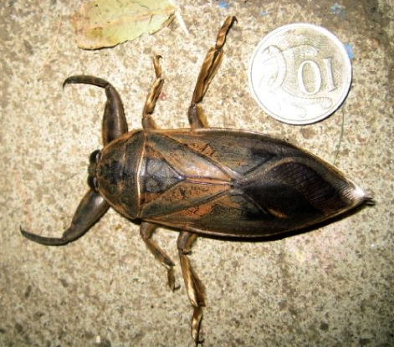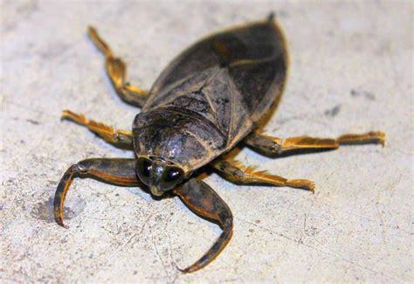

Student Articles
Name: Termites
Scientific Name: Zootermopsis nevadensis
Physical Description: Sonoran Desert termites range in size from 4 to 11 mm. Workers are white with small head capsules. Soldiers have enlarged head capsules, and very formidable jaws, or in one of our species, a snout-like structure.
Description of Habitat: Colonies are built in wood, but some species live underground.
Species Summary: This highly successful group of social insects plays an essential ecological role in the decomposition and recycling of a nutritionally poor, highly resistant, but extremely abundant substance: cellulose. Wood is mostly cellulose, and so are cotton and all paper products. In the Sonoran Desert, trees, shrubs, grasses, and cactus skeletons are the primary source of cellulose.
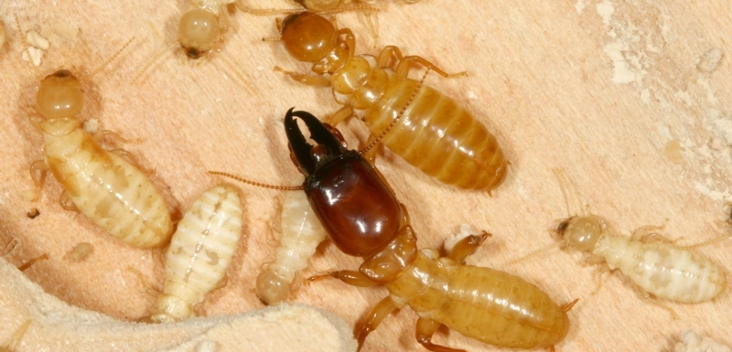

Student Articles
Name: Fiery Searcher
Scientific Name: Calosoma scrutator
Physical Description: Attractive in appearance with its striking bright, metallic colors, it is one of the continent’s largest ground beetles
Description of Habitat: Calosoma scrutator is found primarily in fields and gardens; however, it may also frequent deciduous forests, usually spending the day hiding under logs, rocks, or in crevices, with a preference to hunt at night. It is documented to fly only rarely, but is one of the few species in the genus Calosoma that can climb shrubs and trees in order to forage. Although striking in appearance, these insects should be approached with care. As well as being able to give a nasty bite, most beetles within the genus Calosoma, Calosoma scrutator included, are equipped with scent bladders/glands that can defensively release a fluid with a strong musky odor.
Species Summary: This ground beetle is predatory in both the larval and adult stages, as is typical of the tribe Carabini, thus earning it the common name caterpillar hunter.
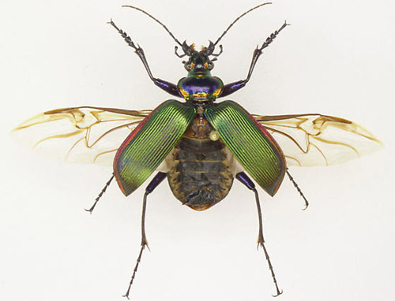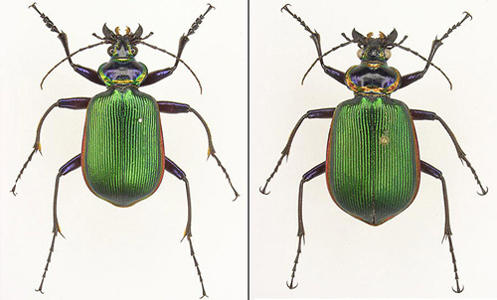

Student Articles
Name: Madrean Jewel Scarab
Scientific Name: Chrysina adelaide, Scarabaeidae
Physical Description: Scarabs are stout-bodied beetles, many with bright metallic colours, measuring between 15-35mm. They have distinctive, clubbed antennae composed of plates called lamellae that can be compressed into a ball or fanned out like leaves to sense odours. The front legs of many species are broad and adapted for digging.
Description of Habitat: The larvae live in rotting logs, while the adults commonly feed on foliage; they tend to be found in pine, juniper, or pine-oak forests, most commonly between 1000-3000m elevation
Species Summary: They are most diverse in countries such as Honduras, where as many as 15 species can be found in a single location. There are only 4 species which occur in the United States. The majority of species are bright green, but metallic silver and gold are also common colors, and may be combined with green,
