The Bio/Diversity Project
Lesson Title: Importance of Biodiversity in the Sonoran Desert

Teacher: Emily Burke and Victoria Howard
Grade Level: 6th
Time: 45 minutes + 5-10 minute pre-assignment

Adapted from: https://www.keslerscience.com/biodiversity-lesson-plan-a-complete-science-lesson-using-the-5e-method-of-instruction/

AZ State Science Standard: | 6.L2U1.13:  - Develop and use models to demonstrate the interdependence of organisms and their environment including biotic and abiotic factors.
Learning Objective: | - Students will be able to explain how all organisms in an ecosystem are interconnected through both biotic and abiotic elements.  - Students will be able to articulate why maintaining biodiversity is critical to a healthy ecosystem.  - Students will be able to articulate how humans depend on and are impacted by ecosystem biodiversity.
Language Objective: (Optional) | N/A
Scientist of the Week: | 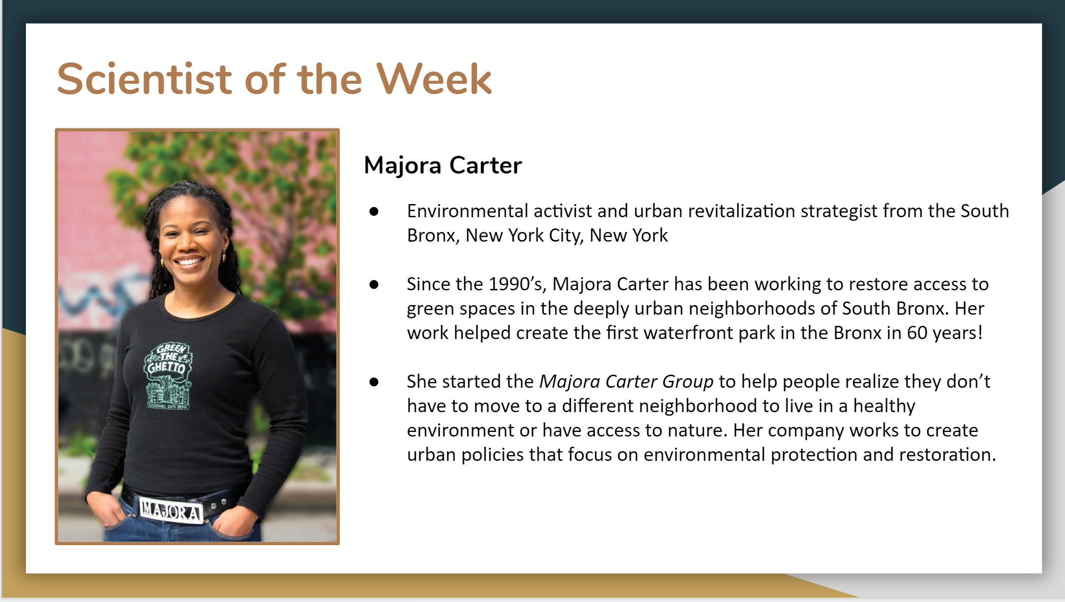

Vocabulary |  |  | Materials
- Culture  - Ecosystem services  - Urban ecosystem  - Sonoran Desert  - Keystone Species |  |  | - Slides  - Biodiversity and Health of Ecosystems Game  - Kahoot!
Seasonality: (If more specificity is required, please note date/time range under the season)

Highlight which season(s) your lesson would be most suited to. When working with the natural world, it is important to keep this in mind for your planning! Some activities are possible for a brief window of time while others may be appropriate during any time of year.

Monsoons  July-Sept. | Autumn  Oct.-Nov. | Winter  Dec.- Feb. |  | Spring  Mar.-Apr. | Dry Summer  May-June
Guiding Questions:

- How do humans rely on biodiversity?
- What impact does biodiversity have on the health and function of an ecosystem?
- What is a keystone species, and why is it important?

5E Steps | Teacher Strategies | Student Behavior
Engagement/Introductory Activity:  This is what you will do to get the students engaged in and excited about the topic of the lesson! It should also provide an opportunity for you to get an idea of what they do (and do not) already know, and the assumptions that they have going into the lesson.  ~10 mins | We will:  - Show objects that are either abiotic or biotic and nonliving, living, or dead.  - Objects include a plastic houseplant, a marker, paper, a seedpod, a pet rat, and petrified wood.  - Discuss what makes something biotic/abiotic, and living, nonliving, or dead.  Focus questions for this discussion:  - What qualities do biotic things have? (e.g. breathing, eating)  - What qualities do abiotic things have? (e.g. no movement, artificial) | Students will define an object shown to them as biotic or abiotic and as living, nonliving, or dead.  Students will then come up with definitions for biotic and abiotic based on their answers/discussion of the objects shown to them.
Exploratory Activity:  Provide step-by-step instructions on what the teacher and students will do in this activity to gain new skills and/or knowledge. Attach worksheets, PowerPoints, video links, or other material used to this section.  ~10 mins | We will explain:  - Plant and animal species are dependent on one another for resources  - Resources are limited so species must compete to obtain the necessary resources  - Food webs describe how different species rely on and compete with each other for energy  - Healthy ecosystems feature diverse species interactions including resource competition.  - One species that multiple species depend on is known as a keystone species.  - An example of a keystone species in the Sonoran Desert is the saguaro cactus. Over 100+ species rely on it for food, shelter and other resources, including birds, insects, and humans.  We will have students predict what will happen if this species disappears. We will connect this to cultural relevance by explaining how the saguaro forest has been depleted by nurse-tree harvesting in Tucson. We will also connect this to how humans (local Native Americans) rely on the cactus for resources. | Students will learn about organism interdependence through seeing a food web.  Students will learn about the Saguaro cactus as a keystone species, and hypothesize what could happen when a keystone species disappears. Students will also learn how local people use and depend on the saguaro.  Students will share their thoughts and predictions either by typing in chat or speaking.
Explain:  What questions or prompts will you use to get students to explain their observations or to explain what the outcomes of the activity that they participated in were? This should provide an opportunity for students to communicate their new understandings, as well as to articulate what they still do not understand.  ~20 mins | - Introduce the concept of ecosystem services, with an emphasis on supporting and cultural services based on the interaction between Native Americans and saguaro cacti.  - Every ecosystem provides services to humans, split into four categories. Provisioning services provide the materials we need to survive, regulating services maintain a healthy environment (e.g. water and air quality), supporting services maintain healthy habitats for other species, and cultural services help humans maintain their mental, emotional, spiritual, and physical wellbeing. For example, the saguaro provides provisioning, cultural, and supporting services.  - Introduce how humans affect biodiversity through an explanation of urban ecosystems and the species that call Tucson streets home.  - Humans build our cities on habitat used by other species for survival. Areas, where many humans, plants, and animals interact/cohabitate, are known as urban ecosystems.  - Some common species seen on the streets of Tucson include Cooper’s hawks, javelina, cottontail rabbits, ground squirrels, bobcats, and coyotes.  - People living in Arizona obtain water resources from the Colorado River. Water travels hundreds of miles to faucets in Tucson.  - Rivers naturally recharge their water supply over time, but humans take water at a faster rate than it can recharge.  - Non-native species can be introduced into an ecosystem through multiple vectors: water, ground, and air travel, or to aesthetically enhance a landscape.  Questions to address:  - What are some common plants or animals that you see in the city of Tucson?  - What kind of impacts do humans have on the ecosystem?  - What are ecosystem services? What services does the saguaro cacti provide?  - What is an urban ecosystem? How does it differ from other ecosystems? | Students will integrate their newly obtained knowledge of saguaro cacti as keystone species by describing which ecosystem services the species provides either verbally or in the chat.  Students will use their personal experiences to share in the chat animals or plants they have seen in urban Tucson.
Extension Activity/Questions:  This section provides an opportunity for students to connect the knowledge that they have gained to other contexts – can they take what they learned and logically expand upon it, or apply it to alternate situations? Provide one or two additional ideas for activities that students can use to expand upon the new knowledge that they have gained.  ~15 mins | We will take 10 minutes to play the “Biodiversity and Health of Ecosystems” Game with the class by sharing our screen while playing:  https://games.legendsoflearning.com/games/WyJnYW1lcyIsNDMyXQ==  - We will have students type in the chat which decision to make (either left or right)  - We will explain to the students that different decisions will have effects on different parts of their virtual ecosystem.  - We will encourage them to try to find patterns in these results while we are playing.  After the time is up, we will ask the students discussion questions:  - What kind of patterns did you recognize in the game?  - What happens if you either fill up or empty a category?  - Why is it important to balance the 4 categories - environment, wildlife, people, and money? | Students will engage in playing the online simulation “Biodiversity and Health of Ecosystems” Game by typing in the chat which decision (left or right) they want us to choose while playing the game with the class.  Students will be encouraged to observe what kind of effects their decisions have on the virtual ecosystem. We will play the game for 10 minutes.  Students will then engage in a directed discussion about the patterns of decisions and their effects in the game.
Evaluation Activity:  How will you evaluate whether or not the students have achieved the learning objective(s) of the lesson?  ~2 mins | We will play Kahoot! with the class. We will need to create the join-code beforehand and give it to students to join.  There will be 5 review questions covering the scope of our lessons and activities?  https://create.kahoot.it/share/lesson-2-evaluation/bd1dcb39-82e8-49ae-b920-1595a70c0d3d  1) Is a pond in the desert biotic or abiotic?  2) What do organisms compete for?  3) What makes something a keystone species?  4) If wood from a tree is used in construction, is that a provisional ecosystem service? (T/F)  5) Do you think biodiversity should be important to us? | Students will play a Kahoot! game to evaluate what they have learned. Students will join the Kahoot! game with a provided link/code and answer five questions (given 10 seconds to answer each).

