The Bio/Diversity Project
Lesson Title: Ecosystem and Biotic Community Diversity

Teacher: Emilly Burke and Victoria Howard
Grade Level: 6th
Time: 60 minutes

Adapted from: https://ecosystems.psu.edu/outreach/youth/sftrc/lesson-plans/wildlife/9-12/habitat

AZ State Science Standard: | 6.L2U3.12  - Develop and use models to demonstrate the interdependence of organisms and their environment including biotic and abiotic factors
Learning Objective: | - Students will be able to identify key characteristics of a habitat  - Students will be able to articulate why both biotic and abiotic factors are needed in an environment
Language Objective: (Optional) | N/A
Scientist of the Week: | 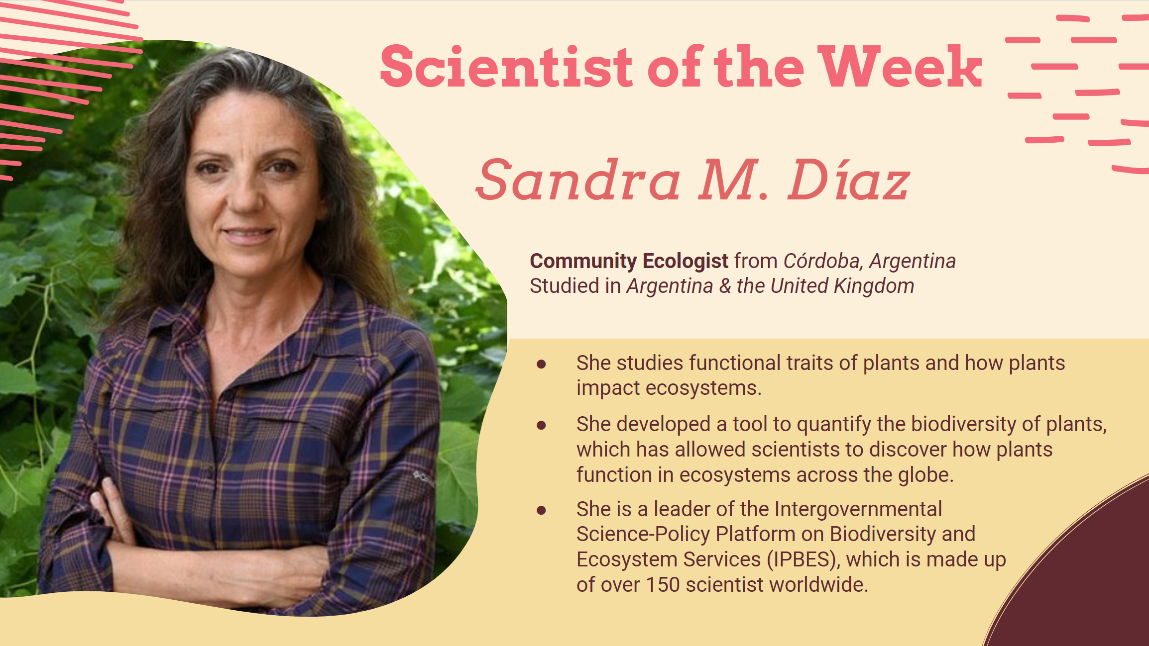

Vocabulary |  |  | Materials
- Biome  - Habitat  - Habitat Fragmentation |  |  | - Slides  - Kahoot
Seasonality: (If more specificity is required, please note date/time range under the season)

Highlight which season(s) your lesson would be most suited to. When working with the natural world, it is important to keep this in mind for your planning! Some activities are possible for a brief window of time while others may be appropriate during any time of year.

Monsoons  July-Sept. | Autumn  Oct.-Nov. | Winter  Dec.- Feb. |  | Spring  Mar.-Apr. | Dry Summer  May-June
Guiding Questions:

- What is a biome?
- What are the critical components of a habitat?
- Why is it important to have both biotic and abiotic factors in an ecosystem?

5E Steps | Teacher Strategies | Student Behavior
Engagement/Introductory Activity:  This is what you will do to get the students engaged in and excited about the topic of the lesson! It should also provide an opportunity for you to get an idea of what they do (and do not) already know, and the assumptions that they have going into the lesson.  ~5 mins | - Review key terms through a quick Kahoot quiz:  - Biotic  - Abiotic  - Community  - Ecosystem  - Introduce new key terms  - Biome  - Habitat  - Ecosystem diversity | Students will participate in a short Kahoot quiz to review essential ecological terms  Students will learn about biomes, ecosystem diversity, and habitat
Exploratory Activity:  Provide step-by-step instructions on what the teacher and students will do in this activity to gain new skills and/or knowledge. Attach worksheets, PowerPoints, video links, or other material used to this section.  ~15 mins | - Describe the biotic and abiotic factors that create each biome  - Abiotic factors include precipitation, nutrient availability, atmospheric conditions, temperature, soil type, and light availability  - Biotic factors include vegetation, animals, fungi, and bacteria  - Explore the biomes of the Sonoran Desert, their unique characteristics, and wildlife exclusive to that area  - Tundra (San Francisco Peaks Ragwort)  - Coniferous Forest (Miniature Saw-Whet Owl)  - Deciduous Forest (Coatimundi)  - Grasslands (Masked Bobwhite Quail and Black-tailed Prairie Dog)  Discussion Questions:  - What biomes are you aware of?  - What biomes do you all think exist in the Sonoran Desert? | Students will learn and discuss the abiotic and biotic factors that control the formation of biomes  Students will emoji bomb the chat with their prediction of which biomes exist in the Sonoran Desert, with a unique emoji assigned to each biome
Explain:  What questions or prompts will you use to get students to explain their observations or to explain what the outcomes of the activity that they participated in were? This should provide an opportunity for students to communicate their new understandings, as well as to articulate what they still do not understand.  ~10 mins | Explain that there are four key components provided by every habitat:  - Food  - Water  - Cover  - Space  Assign students an after-class activity:  - Choose a desert animal you like  - On a piece of paper, draw its habitat  - The habitat must include:  - Something for it to eat  - Somewhere it gets water  - Some kind of shelter  - The space where it lives  Ask students to type what animal they would like to create a habitat for, and to type it in the chat  Show students an example drawing of a desert tortoise habitat  - Food = cactus fruit  - Water = small pond  - Shelter = burrow  - Space = open desert area | Students will learn the four components of a habitat.  Students will choose a desert animal that they would like to create a habitat for in a drawing, and they will type this animal in the chat.  Students will see an example drawing to know what is expected to be included.
Extension Activity/Questions:  This section provides an opportunity for students to connect the knowledge that they have gained to other contexts – can they take what they learned and logically expand upon it, or apply it to alternate situations? Provide one or two additional ideas for activities that students can use to expand upon the new knowledge that they have gained.  ~10 mins | Show students a photo of Mt Lemmon from Tucson. Ask if anyone knows the name of this mountain. Ask students to send a sunglasses emoji in the chat if they have ever been there.  Show students two photos of Mt Lemmon, one from low elevation, and one from high elevation. Ask students, as you drive up the mountain, how does the environment change? How is the bottom different from the top?  Explain a diagram illustrating biome changes with increasing elevation. Explain how the summit is ~20 degrees cooler than the base, gets 200 inches of snow annually, and has unique wildlife.  Present examples of wildlife found on the mountain that are not in the desert  - White-tailed deer  - Black bears  - Ring-tails  - Grey Fox  - Mountain Kingsnake  - Mountain Chickadee | Students will guess the name of the mountain in the picture if they know it. They will send the sunglasses emoji in the chat if they have ever been to Mt Lemmon.  Students will engage in discussion to compare/contrast the environments at the top and bottom of the mountain.  Students will relate this to a diagram showing how biomes change as elevation increases, and how this affects Mt Lemmon’s biomes.  Students will learn different animals that are unique to the mountain, which do not live in the desert.
Evaluation Activity:  How will you evaluate whether or not the students have achieved the learning objective(s) of the lesson?  ~10 mins | Show students a unique biomes/habitat, and ask them to guess which of 3 animals would live there by typing 1, 2, or 3 in the chat:  - Desert  - Black Bear  - Bison  - Rattlesnake  - Grasslands  - Mountain Lion  - Prairie Dog  - Yaqui Catfish  - Forests  - Mule Deer  - Barrel Cactus  - Gila Monster | Students will choose which of 3 possible animals live in either a desert, grassland, or forest by typing either 1, 2, or 3 in the chat.  They will then be shown the correct answer.

