The Bio/Diversity Project
Lesson Title: Calculating Biodiversity/Bioblitz

Teacher: E. Burke, A. Snyder, C. Henderson, P. Smith, K. Tham
Grade Level: 6th
Time: 60 mins

Adapted from: https://www.nationalgeographic.org/activity/introducing-biodiversity-and-bioblitz/
Nearpod Link: https://share.nearpod.com/e/CE7dvveYneb

AZ State Science Standard: | Copy and paste the Arizona State Science Standard(s) that your lesson addresses here.  For example:  5.L4U3.11:  - Develop and use models to demonstrate the interdependence of organisms and their environment including biotic and abiotic factors.
Learning Objective: | - Students will be able to explain how all animals and plants are part of food webs and depend on one another as well as their environment for survival  - Students will be able to articulate why maintaining biodiversity is critical to a healthy habitat
Language Objective: (Optional) | N/A
Scientist of the Week: | 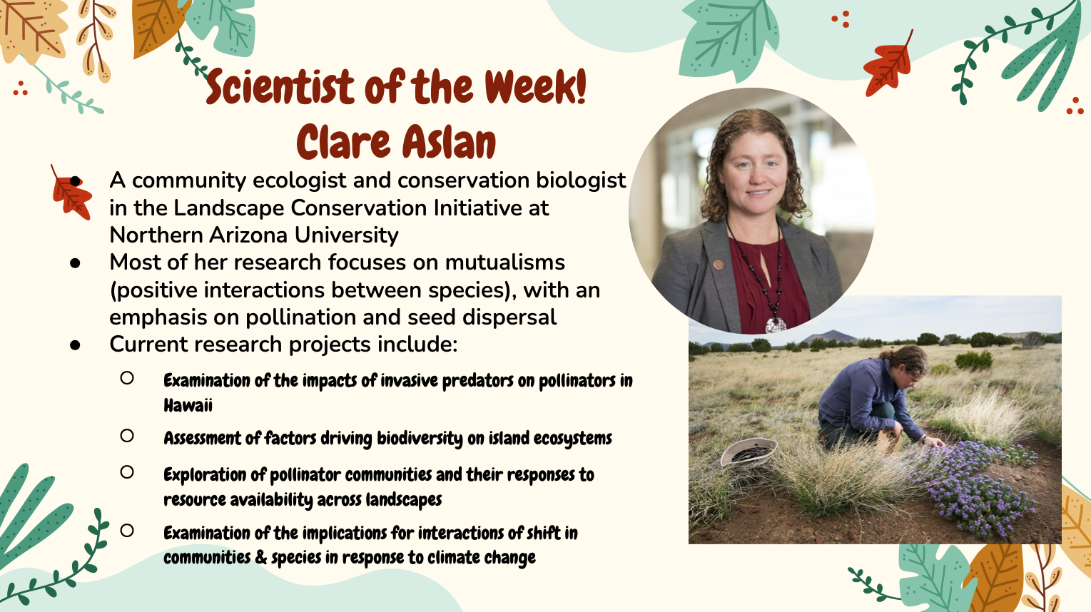

Vocabulary |  |  | Materials
Provide a bulleted, alphabetized list of words that students will hear, speak, write, and/or read about in the lesson. Please do not list more than 4-5 words. These words must be integral to developing content understanding. You may copy and paste these directly from the Scope and Sequence Guide document.  For example:  - Biodiversity  - Biome  - Ecosystem |  |  | Provide a bulleted and hyperlinked list of relevant materials for the lesson.  For example:  - Slides  - Nearpod  - Bird Feeder Video  - Hummingbird Info (for intern research)  - Hummingbird audio  - iNaturalist.org (for lesson)  - iNaturalist Explore (for field journal assignment)  - Kahoot  - Kahoot Question Guide
Seasonality: (If more specificity is required, please note date/time range under the season)

Highlight which season(s) your lesson would be most suited to. When working with the natural world, it is important to keep this in mind for your planning! Some activities are possible for a brief window of time while others may be appropriate during any time of year.

Monsoons  July-Sept. | Autumn  Oct.-Nov. | Winter  Dec.- Feb. |  | Spring  Mar.-Apr. | Dry Summer  May-June
Guiding Questions:

Write down bulleted, guiding questions that you will ask students in order to promote a deeper understanding of the subject matter. These are questions you will ask students to open the conversation on this topic. You may copy and paste these directly from the Scope and Sequence Guide document.

For example:

- What are examples of migratory bird pollinators in the Sonoran Desert?
- How is biodiversity calculated?
- Why is it important to calculate biodiversity?

5E Steps | Teacher Strategies | Student Behavior
Engagement/Introductory Activity: Emily  This is what you will do to get the students engaged in and excited about the topic of the lesson! It should also provide an opportunity for you to get an idea of what they do (and do not) already know, and the assumptions that they have going into the lesson. | - Show students the video of Emily’s bird feeders in her backyard with an explanation as to what attracts specific birds to certain feeders, as well as a tutorial as to how to make their own hummingbird feeders at home.  - Show students the 5 common hummingbirds they can see in the Sonoran Desert and describe their defining features:  - Broad-billed hummingbird: males are metallic blue/green, females are a dull green, have forked tail feathers and a red base of their beak  - Black-chinned hummingbird: iridescent green above and dull grey underside, with a black or violet throat  - Anna’s hummingbird: “flame” throated, iridescent green and grey body, males have the characteristically rose colored throat whereas females are more dull  - Costa’s hummingbird: “flame” throated, iridescent green above and grayish white below, males have an iridescent amethyst purple forehead and throat that extends into an elongated “mustache.” The female completely lacks these patches.  - Rufous hummingbird: They are cinnamon-rufous colored on the upper parts, tail, and lower breast and belly. In good light, the male’s throat iridescens a metallic orange to scarlet. The female is more iridescent bronze-green above and dull white below.  - Play an example (~15 seconds) of hummingbird calls (of Anna’s hummingbird from ASDM website) | - Students will watch a video detailing how certain birds are attracted to feeders, as well as how they can make their own feeder at home.  - Students will learn identifying characteristics of the 5 common hummingbirds in the Sonoran Desert  - Students will listen to an audio clip of hummingbird sounds
Exploratory Activity: Kristie 2  Provide step-by-step instructions on what the teacher and students will do in this activity to gain new skills and/or knowledge. Attach worksheets, PowerPoints, video links, or other material used to this section. | We will explore the topic of biodiversity starting with the breakdown definition of Biodiversity.  On screen will be a color coded definition of biodiversity and the meaning of each prefix. | Students will use an interactive nearpod slide and start marking the biodiversity of plants and animals of the Sonoran Desert  We will work together to see  - How many [cacti/snakes/birds] are there?  - Do all the [cacti etc] look the same?  Now that we’ve counted all the plants and animals, calculated the biodiversity, how do we keep track of our data?
Explain: Antonia 3&4  What questions or prompts will you use to get students to explain their observations or to explain what the outcomes of the activity that they participated in were? This should provide an opportunity for students to communicate their new understandings, as well as to articulate what they still do not understand. | - For the explain activity we will start by showing students this video  - We will ask students “How many species of birds, reptiles, mammals, insects , and plants do you guys think are in the sonoran desert?” on nearpod collaborative board.  - Answer: There are 350 Birds, 100 reptiles, 60 mammals, 2000 plants, and over 1000 insects in the Sonoran Desert.  - We will then go over the answer of how many different species the sonoran desert has.  - We will ask students how they think taxonomy relates to biodiversity on nearpod collaborative board.  - Answer: Taxonomy helps us better understand biodiversity by separating living organisms into groups based on certain characteristics. | - Students will watch a video on taxonomy and learn what taxonomy is.  - Students will learn about taxonomy and be able to identify the importance of it in biodiversity  - students will learn about the different species of animals and plants in the sonoran desert.
Extension Activity/Questions: Peyton 5&6  This section provides an opportunity for students to connect the knowledge that they have gained to other contexts – can they take what they learned and logically expand upon it, or apply it to alternate situations? Provide one or two additional ideas for activities that students can use to expand upon the new knowledge that they have gained. | - Remind students that biodiversity is everywhere: from the deepest oceans, to the tropical rainforests, and in our own backyard (the Sonoran Desert).  - Explain to students that the class will engage in a bioblitz—a short, intensive study of the biodiversity of an area. These should be brief and exciting!  At this point, switch from the nearpod slides to iNaturalist.org  - Use the University of Arizona as the first location, then allow students to pick three others. Ask students, “What do you see?”  Try to identify as many migratory bird species as you can!  - For each location, different species will be discussed and identified in order to magnify how biodiverse ecosystems are.  Switch back to nearpod.  - Ask students to discuss on a nearpod collaborate board their answers to this question:  - “What have you learned about biodiversity today?”  Field Journal Assignment  - For this week’s field journal assignment, explain to students that they are to log on to iNaturalist.org and navigate to the explore tab. From here, students may search any location they can think of, and are asked to take notes of at least 3 different species in their desired location in their field journals. | - Students will be reminded that biodiversity is not just seen in the Sonoran Desert, but rather, everywhere!  - Students will engage in a bioblitz. They are expected to view the instructor’s screen as they look over the species submissions around the University of Arizona.  - Students will then be instructed to volunteer a location of their own to engage in 3 more bio-blitzes.  - Students are encouraged to participate via microphone and chat.  - Students will then reflect on a nearpod collaborative slide on what they have learned about biodiversity. They are encouraged to participate via microphone and chat to share whatever they are thinking about biodiversity.  - Students will then be informed about this week’s field assignment, which entails using iNaturalist.org and the explore tab to choose any location they want. From there, students will record at least three of the species they found in their field journal.
Evaluation Activity:  How will you evaluate whether or not the students have achieved the learning objective(s) of the lesson? | - Students will have a recap of what they learned through a Kahoot  - Questions will cover what was discussed in class  - Question Guide, which include questions, answers, and explanations | - Students will log onto Kahoot and answer 5 questions from the lesson plan to the best of their ability  - Students should ask any questions and participate in the discussion between every question

