Bio/Diversity Project
Lesson Title: Specific Pollinators: Hummingbirds, Birds, and Bats

Teacher: Gricelda Meraz
Grade Level: 6th
Time: 80 minutes

AZ State Science Standard: | 6.L2U1.13  - Develop and use models to demonstrate the interdependence of organisms and their environment including biotic and abiotic factors
Content Objective:  Math, Reading, Science, Writing, Other: | - Students will be able to identify what qualities make a pollinator-plant pair compatible  - Students will be able to identify Sonoran Desert pollinators and plants.
Language Objective: (Optional) | N/A
Scientist of the Week: | - Kathrin Barboza Marquez  - Bolivia  - Bat Biologist  - Discovered the sword nosed bat thought to be extinct for 72 years  - Researching bat bio-acoustics

Vocabulary |  |  | Materials
- Pollination syndrome |  |  | - Headbands  - Specimens (bats and birds)  - Cards with Sonoran Desert  pollinators and plants
Seasonality: No specific seasonality required
Monsoons  July-Sept. | Autumn  Oct.-Nov. | Winter  Dec.- Feb. |  | Spring  Mar.-Apr. | Dry Summer  May-June
Guiding Questions:

- What factors influence a pollinator to choose a flower?

Engagement/Introductory Activity:
- Show students pictures of Sonoran Desert flowers and ask students to write down a 2 sentence explanation for why one of the flowers is their favorite.
- Think/Pair/Share of which flower students' chose and why.
- Explain to the students that just like they prefer some flowers over others, so do pollinators. For example, the hummingbird has a long, slender beak, they prefer flowers that are long and tube-like. For bats, a large flower with strong smells to land on is prefered. For these pollinators, a wide-open flower is preferred. For moths, a flower that is open at night is preferred because that is when moths are active. The concept of pollinators preferring some plants over others is known as 'Pollinator Syndromes.'Pollinators have certain characteristics that are specific to their preferred plants.
  - Plant and Pollinator Pairs:
    - Chuparosa = Hummingbird
      - Daytime blooms, presence of nectar, and tube shape all support that a hummingbird could pollinate this flower effectively
    - Smooth Desert Dandelion = Bee
      - Daytime blooms, sturdy petal platform, UV light patterns all support bee pollination. Sweet scent, daytime blooms, and sturdy platform support fly pollination.
    - Desert Lily = 1. Moth, 2. Bat
      - Nighttime blooms, tube shaped flower, white coloration, and strong smell support moth pollination. Nighttime blooms, large flowers, and strong smell support bat pollination.
    - Starfish Cactus = 1. Moth
      - Daytime blooms, strong smell both support fly pollination. Strong smell supports moth pollination.
    - Dakota Mock Vervain = 1. Butterfly, 2. Bee
      - Bright coloration, small, long-tube shaped flowers support butterfly pollination. Bright colors and many small flowers support bee pollination.
    - Yellow Palo Verde = Bee
      - Daytime blooms, sturdy petals, and UV light pattern all support bee pollination.Parry’s Agave = 1. Bat, 2. Moth
    - Parry’s Agave = 1. Bat, 2. Moth
      - Nighttime blooms, strong smell, and sturdy petal platform with large flowers all support bat pollination. Smell, nighttime blooms both support moth pollination.

Exploratory Activity:
- We will assign each student a picture of either a Sonoran Desert plant or their pollinator
- Each student with a plant picture will try to pair up with their most effective pollinator
  - The students will not know what is on their picture
  - The picture will be connected to a headband (similar to the game HeadsUp).
- Each student will have a set of factual clues on their headband to help them find a pollinator or plant that
fits into a working pair
- The activity will continue until each student is paired up with a pollinator or plant, they believe they could have a symbiotic relationship with

Explain:
- Students will look at and compare their headbands and determine if they chose an effective pollinator.
- Think/Pair/Share: what characteristics do the plants have in common with their pollinator?
- In a class discussion, ask for volunteers who think their pair was especially compatible or especially
incompatible to tell the class why.

Extension Activity/Questions:
- Students will go to the 3 stations where the specimens are located
- Have students fill in there journal answering questions
  - How is the animal adapted to the plant it pollinates?
    - List 2 specific parts and their function
  - What type of flower would it be attracted to?

Evaluation Activity:
How will you evaluate whether or not the students have achieved the learning objective(s) of the lesson?
- Exit ticket: draw your favorite pollinator and a plant they pollinate.

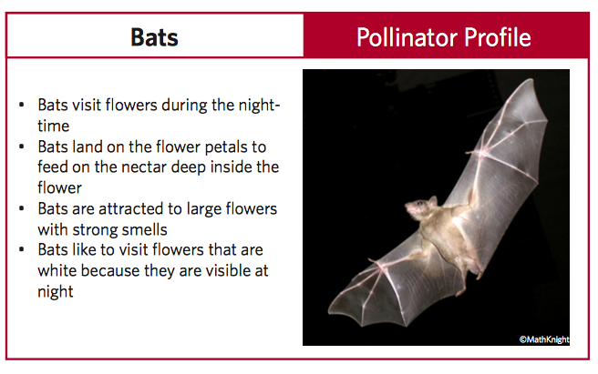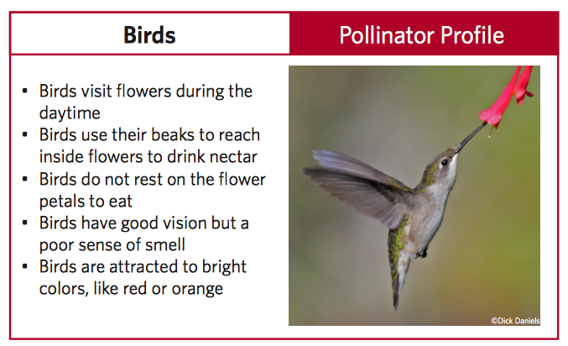

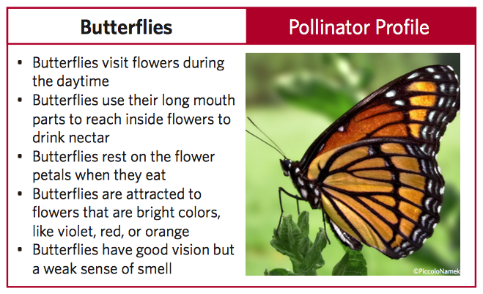
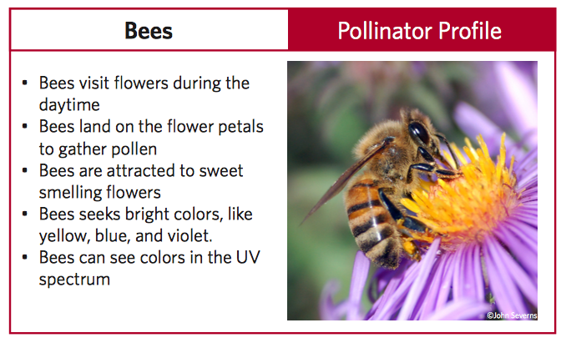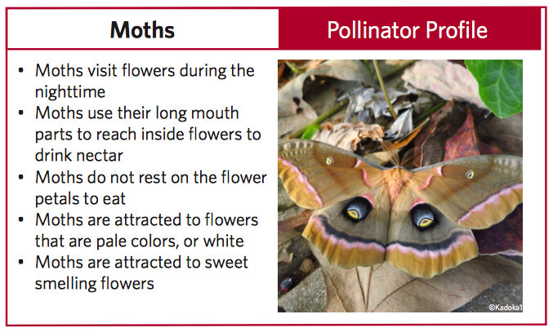

Flower Characteristics
- What color am I?
- Do I bloom during the day? Do I bloom at night?
- Am I a long flower?
- Am I a large flower? A small flower?

Pollinator Characteristics
- Am I active during the day? At night?
- Does (color) attract me?
- Do I rest on flowers?
- Do I use my vision?
- Am I attracted to strong smells?

