The Bio/Diversity Project
Lesson Title: Adaptations of Desert Animals and Humans

Teacher: Emily Burke + Victoria Howard
Grade Level: 6th
Time: 1 hour
Adapted from: http://www.desertmuseum.org/center/edu/docs/4-12_ex_adapt_into_previsit.pdf
https://www.nps.gov/sagu/learn/education/upload/Unit%204%20-%20Adapting%20to%20Desert%20Living.pdf

AZ State Science Standard: | 6.L2U3.11  - Use evidence to construct an argument regarding the impact of human activities on the environment and how they positively and negatively affect the competition for energy and resources in ecosystems.  6.L2U3.12  - Engage in argument from evidence to support a claim about the factors that cause species to change and how humans can impact those factors.
Learning Objective: | - Students will be able to articulate why structural and behavioral adaptations are necessary for animals to survive in the Sonoran Desert.  - Students will be able to describe at least 3 adaptations specific to animal species in the Sonoran Desert.  - Students will be able to explain how ancient and modern humans have adapted to life in the Sonoran Desert.
Language Objective: (Optional) | N/A
Scientist of the Week: | 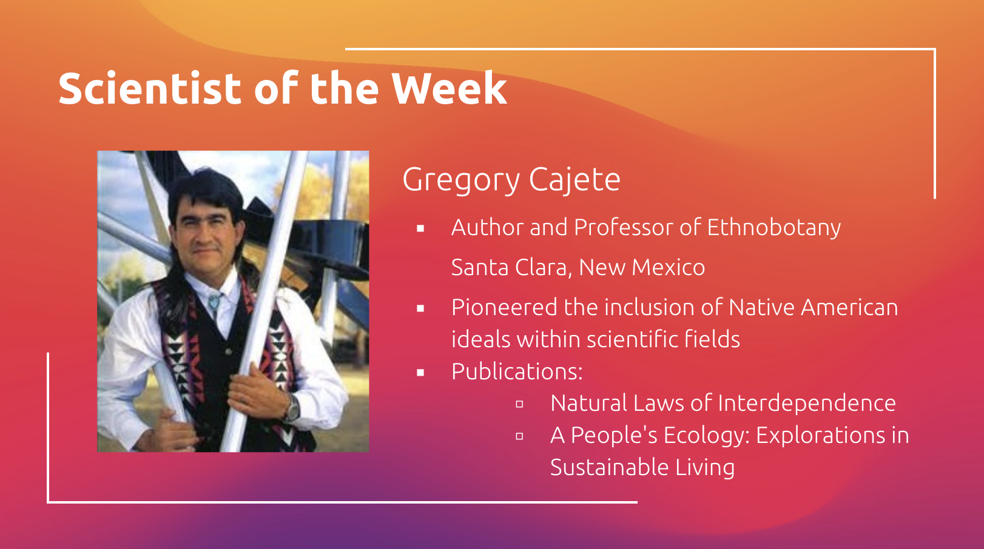

Vocabulary |  |  | Materials
- Adaptation  - Evolution  - Survival  - Thermoregulation |  |  | - Kahoot!  - Slides
Seasonality: (If more specificity is required, please note date/time range under the season)

Highlight which season(s) your lesson would be most suited to. When working with the natural world, it is important to keep this in mind for your planning! Some activities are possible for a brief window of time while others may be appropriate during any time of year.

Monsoons  July-Sept. | Autumn  Oct.-Nov. | Winter  Dec.- Feb. |  | Spring  Mar.-Apr. | Dry Summer  May-June
Guiding Questions:

- What techniques did ancient humans, such as the Hohokam, use to survive extreme weather in the Sonoran Desert?
- Why do animals need to adapt to the desert climate and conditions?
- What role does evolution play in adaptations?

5E Steps | Teacher Strategies | Student Behavior
Engagement/Introductory Activity:  This is what you will do to get the students engaged in and excited about the topic of the lesson! It should also provide an opportunity for you to get an idea of what they do (and do not) already know, and the assumptions that they have going into the lesson.  ~10 mins | - Show pictures of our pets, and speak briefly about them.  - Ask students if they have pets, what kind, and what they’re like - type their species and name in the chat.  - We will talk about how we observe pets react when it is hot out (drinking water, panting, laying in shade, etc).  - Ask students if they notice the same/similar things (s).  - Ask students to define ‘adaptation’. | Students will be introduced to the teachers’ pets, and will type in the chat the name of their pets and what kind of pet they have.  Students will understand how pets/animals commonly respond to heat.  Students will explain what ‘adaptation’ means.
Exploratory Activity:  Provide step-by-step instructions on what the teacher and students will do in this activity to gain new skills and/or knowledge. Attach worksheets, PowerPoints, video links, or other material used to this section.  ~10 mins | We will play a “Guess Who?” game:  We will provide descriptions of the adaptations of 3 different Sonoran Desert organisms (Creosote, Black-tailed Jackrabbit, and Javelina), and ask students to try to guess the animal.  We will ask them to send their guesses in the chat using a ‘chat bomb’ before we reveal the answer. | Students will be given descriptions of adaptations from five different Sonoran Desert organisms. They will ‘chat bomb’ their guess as to what organism has those adaptations before the answer is revealed.
Explain:  What questions or prompts will you use to get students to explain their observations or to explain what the outcomes of the activity that they participated in were? This should provide an opportunity for students to communicate their new understandings, as well as to articulate what they still do not understand.  ~15 mins | - Present a formal definition of adaptations, as well as behavioral and physical adaptations.  - Explain that there are 5 major kinds of adaptations needed to thrive in the Sonoran Desert.  - For each, we will provide one example of Sonoran species with either a behavioral or physical adaptation, and have students guess which adaptation type it is using emoji responses in chat.  - Feeding  - Owl Eyes (P)  - Moving around  - Roadrunner feet structure (P)  - Thermoregulation  - Desert Tortoise burrows (B)  - Water Conservation  - Saguaro water storage and root system (P)  - Protection  - Horned toad blood tears (P/B) | Students will receive a formal definition of adaptations, as well as physical and behavioral classifications of adaptations.  Students will view examples of five different kinds of adaptations. For each type, there will be one example, either physical or behavioral adaptation.  Students will use reaction emojis in the chat to guess which adaptation type is shown.
Extension Activity/Questions:  This section provides an opportunity for students to connect the knowledge that they have gained to other contexts – can they take what they learned and logically expand upon it, or apply it to alternate situations? Provide one or two additional ideas for activities that students can use to expand upon the new knowledge that they have gained.  ~15-20 minutes | - Work through a timeline of the thousands of years of human settlement in the Sonoran Desert, from Hohokam -> Tohono O’odham -> Spanish Colonization -> Modern Day.  - Describe cultural and behavioral adaptations made by ancient cultures to survive living in the Sonoran Desert.  - Human adaptations to the desert include using natural caves as shelter, agriculture and irrigation, specialized clothing, seasonal migration, and living near water.  Questions:  - Are any of the adaptations still used today?  - Where do humans in the Sonoran Desert get resources like food and water from today?  - How do you adapt to living in the desert? | Students will learn about the history of human settlement in the Sonoran Desert by engaging with a timeline of the people and cultures that have made the Tucson area their home.  Students will view examples of human adaptations in the desert and connect them to the animal adaptations previously discussed.  Students will share how they adapt to living in the desert.  Students will respond to questions by typing in chat and reacting with emojis.
Evaluation Activity:  How will you evaluate whether or not the students have achieved the learning objective(s) of the lesson?  ~5-10 minutes | Play Kahoot! with the class, link here.  Questions:  - What is an adaptation?  - Are most human adaptations behavioral or structural?  - What kind of adaption is a cactus spine?  - Horned lizards shooting blood out of their eyes is a defense adaptation. (T/F)  - What kind of adaptation is a jackrabbit’s large ears? | Students will join a Kahoot! game to evaluate what they learned over the course of the lesson.  The join code will be shared with them and they will be given 20 seconds to answer each question.

